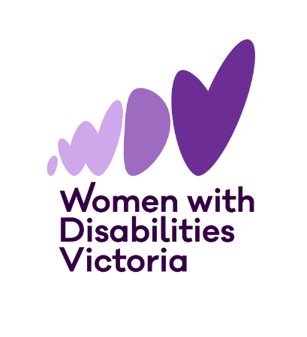



Information and Application Form
The Victorian
Enabling Women Leadership Program
Autumn, 2026
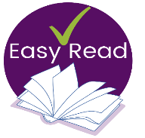

Please Note:
If you need help or would like an Easy Read version of this form, please contact Bridget Jolley (she/her).


Email: leadership@wdv.org.au
Txt / Phone: 0459 322 479

About WDV
Women with Disabilities Victoria (WDV) is an organisation run for and by women and gender diverse people with all kinds of disabilities.

Our members are people of all ages, backgrounds and lifestyles. We strive to be a safe and inclusive service for all women and gender diverse people.
We advocate for our right to safety and respect with a focus on empowerment and leadership.

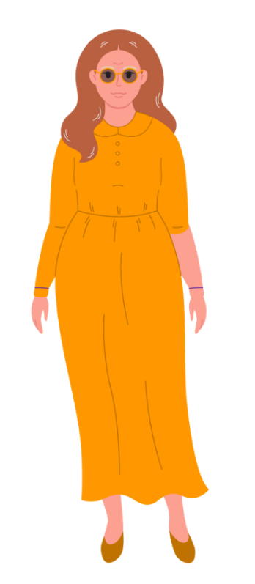
About Enabling Women
The Victorian Enabling Women Leadership Program (the Program) is a community-based Program, where we explore leadership in fun and meaningful ways.

During the Program you will also work with a mentor, who will support you to achieve a leadership goal.

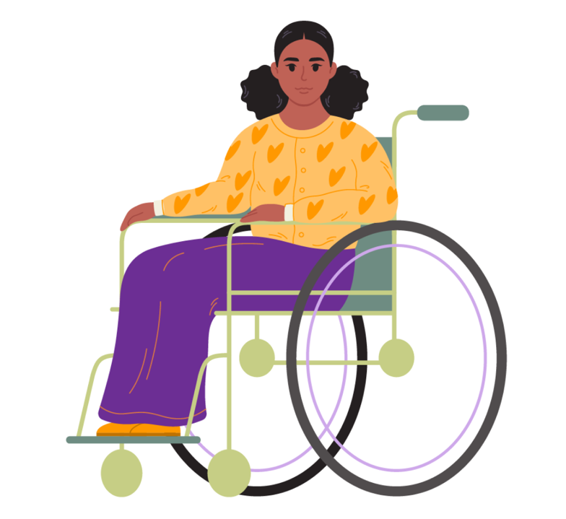
The Program will be delivered in a hybrid way. You can choose to attend in person at WDV’s office in Melbourne’s CBD, or online via Zoom.
There will be up to 14 participants.

Program sessions and the Graduation will held be on Wednesdays.
There will be 8 program sessions, that will each run for 3 hours. Breaks will be included.

Program sessions will be held 1-4pm and run on Wednesdays March 25 – June 10. Sessions are NOT weekly.
On June 17 we will hold a Graduation event to celebrate your success of completing the Program.

Session Dates
Session 1 – March 18 | Session 2 – March 25
Session 3 – April 1 | Session 4 – April 15
Session 5 – April 29 | Session 6 – May 13
Session 7 – May 27 | Session 8 – June 10
Graduation – June 17

The program is open to:
- Women and gender diverse people, who are
- aged 18+ and who
- live, work, study or play in the state of Victoria, and
- identifies as someone
- with disability (physical, sensory, intellectual, cognitive, etc.)
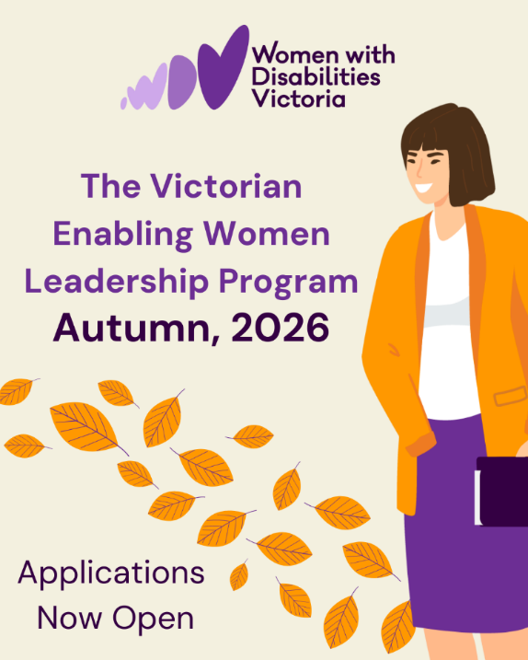
- who is Deaf / deaf / hard of hearing
- who lives with chronic illness, and / or pain
- who is neurodiverse, e.g. autistic, lives with ADHD, OCD, learning disabilities, tics, etc.
- who lives with mental health challenges.

Completing the Application form
Application forms can be completed electronically, by hand, or by recording your answers in a video or audio recording.
There is also an Easy Read version of this Application Form.
Please contact Bridget at WDV for a copy -
Email leadership@wdv.org.au, or txt / call 0459 322 479 for a copy.
If you are using a computer to fill out the below form, you can check boxes with a mouse click or use the spacebar key on the keyboard.
Completed applications should be emailed to Bridget at leadership@wdv.org.au

If you are submitting a video or audio version, please email Bridget at leadership@wdv.org.au, or txt / call her on 0459 322 479 to discuss how to send the file.


Help and More information
Do you have questions or need help to fill out this form?
If you would like more information, or help to fill out this form, please contact Bridget.
Txt / Phone: 0459 322 479
Email: leadership@wdv.org.au

Application Form

Your details
Information required | Your response
First name
Family name
*Optional* Pronouns E.g.. she/her or they/them, they/him
Year of birth
Postal address

Suburb
Postcode
Phone number
Email

*Optional* Do you identify as Aboriginal and/or Torres  Strait Islander? | ☐ Yes – Aboriginal  ☐ Yes – Torres Strait Islander  ☐ No
Do you speak a language other than English at home? | ☐ Yes. What language/s?  ☐ No

Questions about you
Information required | Your response
1. What are your passions and interests?
2. Why are you interested in doing this program?
3 a. Thinking about your gender, and disability, (or other areas of life) what things may stop you from doing the things you want to do?
3 b. Have you been able to overcome this? | ☐ Yes  ☐ No
3 c. If yes, what did you do?

4. What connections do you have with the state of Victoria? (E.g. where you live, work, study, etc.)

5. Do you currently, or have you previously participated in any WDV Programs / projects? What were they?

6 What groups are you currently, or have you previously been a part of? What do / did you do with the group? E.g. Group committees, sporting clubs, Church groups, committees,

7. How did you hear about the Enabling Women Leadership Program?

Participation Questions
Requirement | Your Response
1. Do you expect to participate mostly in person, or online? | ☐ In person  ☐ Online  ☐ It depends / unsure
2. Do you have access to a computer or tablet, with internet at home? | ☐ Yes – computer  ☐ Yes – tablet  ☐ No
3. Is the internet connection reliable? | ☐ Yes  ☐ No  ☐ Sometimes
4. If you have a computer, does it include these things? | ☐ Microphone  ☐ Webcam  ☐ Speaker  ☐ Headphones
5. If you do not have the right equipment at home, and you want to participate online, what can we do to support you?
6. Have you done an online video meeting before? | ☐ Yes – Zoom  ☐ Yes – But not Zoom. Please tell us what did you use?  ☐ No
7. Would you like any help to use Zoom? | ☐ Yes – please tell us in what ways?  ☐ No  ☐ Not sure
8. At times we may talk about confronting topics (for example, gender based violence).  If talking about uncomfortable topics, when do you feel most safe? | ☐ Participating online from home by myself  ☐ Being part of a friendly group setting  ☐ Not sure  ☐ Other / it depends

Support and access
Requirement | Your Response
Are there any access requirements, or supports that may help you to fully participate? | If you think you may need one of these supports, please tick the box and provide more information if requested.
Captions | ☐ If yes, automatic, or live captions? Or unsure?
Interpreter | ☐ If yes, what language?
Attendant care (to help with eating, going to the bathroom, etc.) | ☐
Note-taker | ☐
Wheelchair access | ☐
Dog guide / Service animal facilities | ☐ If yes, what requirements?
Transport / accessing the venue | ☐ If yes, what requirements?
Information in alternative formats | ☐ If yes, what formats?
Dietary requirements | ☐ If yes, what requirements?
Do you have any other access or participation requirements? | ☐ If yes, what requirements?

Completed applications should be emailed to Bridget Jolley at WDV - leadership@wdv.org.au.
If you have questions, or want to submit a video or audio version, please email leadership@wdv.org.au, or txt / call Bridget on 0459 322 479 to discuss how to send the file.
Thank you for your application!

