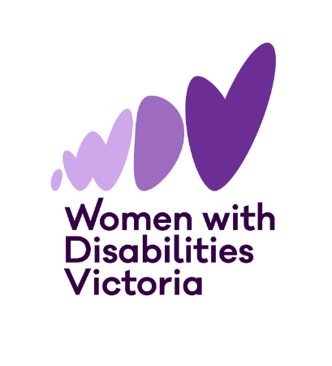


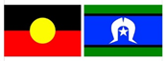

The Victorian
Enabling Women Leadership Program
Autumn, 2026

Do you want to become a stronger leader?
Are you someone who identifies as a woman or gender diverse person with disability?
Are you connected with the state of Victoria?
Come join us, and become the leader you want to be, as part of the Enabling Women Leadership Program!
You will:

- build confidence
- explore who you are
- reflect on your strengths (the things you’re good at)
- learn more about your human rights
- practise speaking up
- work with a mentor to achieve a leadership goal
- become a better leader in your community.
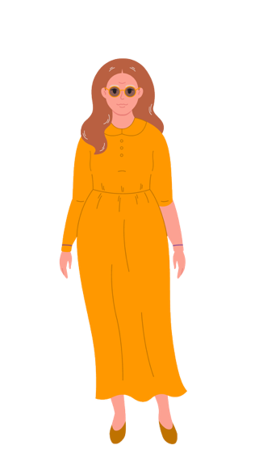
Where: In person at WDV’s Melbourne office, or online via Zoom
What: 8 x 3-hour group program sessions, 5 individual mentor sessions, and a Graduation Celebration
When: Program sessions and the Graduation will
be held on Wednesdays at 1-4.00pm.
Cost: FREE

Session Dates
Session 1 – March 18 | Session 2 – March 25
Session 3 – April 1 | Session 4 – April 15
Session 5 – April 29 | Session 6 – May 13
Session 7 – May 27 | Session 8 – June 10
Graduation – June 17

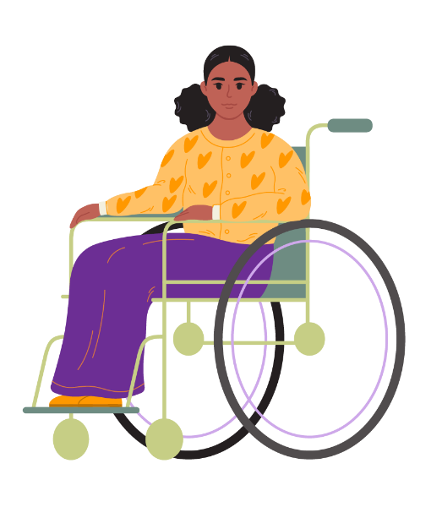
Included in the Program:
- All materials – folder, workbook,
activity and craft supplies, etc.
- Access supports
- Snacks




To find out more, and to apply:
To ask questions about the Program, or to get help completing an application form, please contact Bridget Jolley (she/her)
Email: leadership@wdv.org.au
Txt / Phone: 0459 322 479

