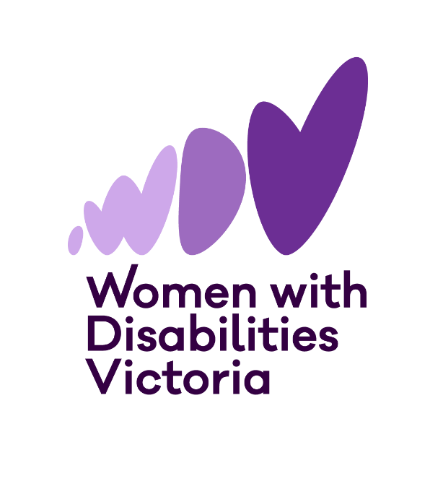




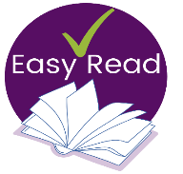
Information and Application form for


The Victorian Enabling Women
Leadership Program
Autumn, 2026




Questions and help to apply
Do you want more information, or help to apply?


You can contact Bridget (she/her) at WDV.
Email: leadership@wdv.org.au
Phone: (03) 9286 7813

Introduction to the Enabling Women Leadership Program
Women with Disabilities Victoria (WDV) is an organisation run for and by women and gender diverse people with all kinds of disabilities.


Our members are people of all ages, backgrounds and lifestyles.
We are a proud LGBTIQA+ ally.
We want to be a safe space and to include all women and gender diverse people with disabilities.
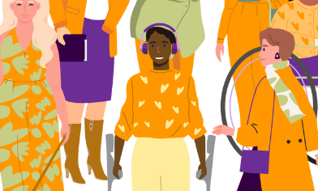
We focus on rights to safety and respect.
This includes being able to speak up for ourselves and being leaders.

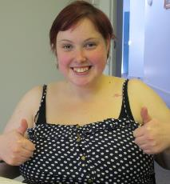
In The Enabling Women Leadership Program (also known as the Program) women and gender diverse people with disability learn how to become stronger leaders.
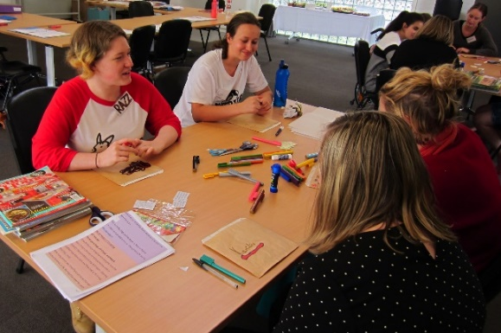

We do this in fun and meaningful ways.

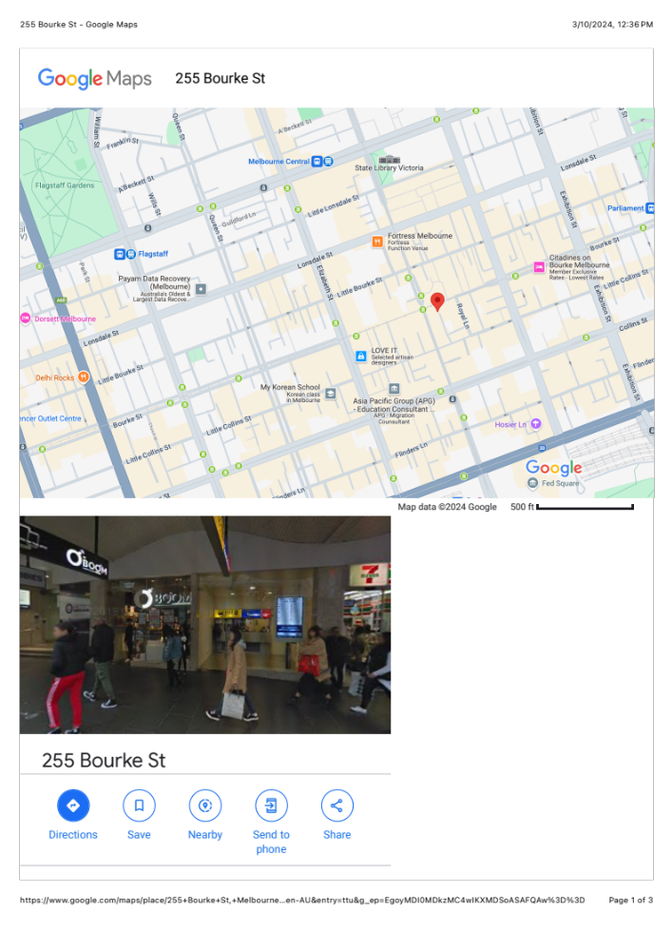
The Program will be hybrid.
This means you can attend in person at the WDV Office in Melbourne CBD

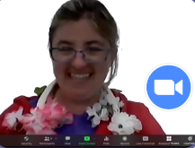
Or

Online via Zoom.


The Program will have up to 14 participants.

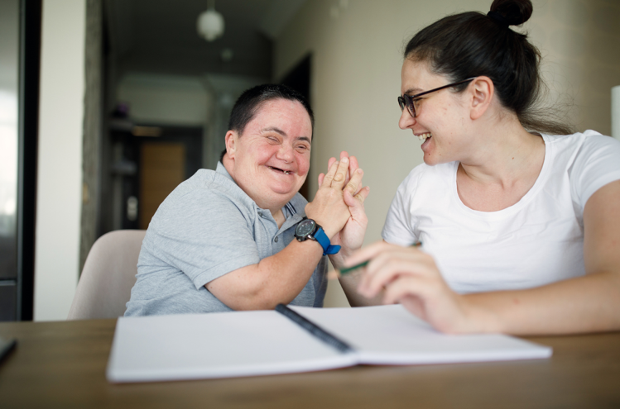
During the Program, participants will work with a mentor.
Mentors support people to achieve a goal.

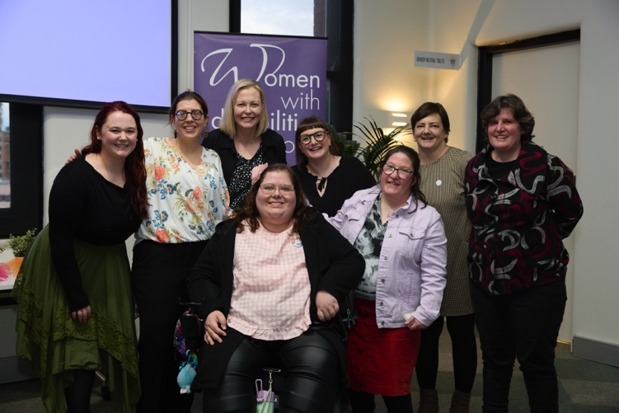

The Program will finish with a Graduation celebration.



There will be 8 Program sessions.

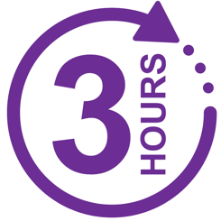
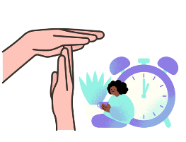
Sessions will run from 1:00 – 4:00pm
Each session will be 3 hours long
Sessions will include breaks.


Program sessions will be on Wednesdays, 1:00 – 4:00pm.
But not every Wednesday.

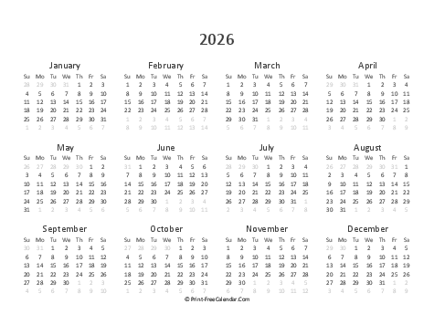
Program sessions will run from March 18 – June 10, 2026
A Graduation celebration will be held on June 17, 2026.

Key Dates:
Session 1 – Wednesday, March 18
Session 2 – Wednesday, March 25
Session 3 – Wednesday, April 1
Session 4 – Wednesday, April 15
Session 5 – Wednesday, April 29
Session 6 – Wednesday, May 13
Session 7 – Wednesday, May 27
Session 8 – Wednesday, June 10

Graduation – Wednesday, June 17

Who can participate?

You can participate, if you

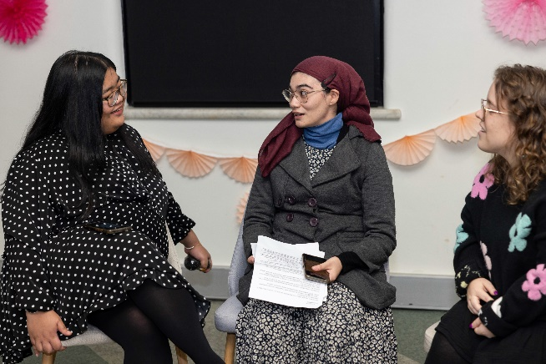
- are a woman or gender diverse person, who is

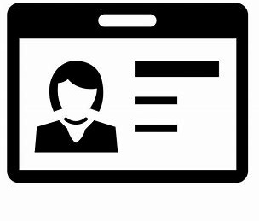

- aged 18+, and

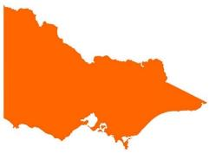
- lives, works, studies, volunteers or plays in the state of Victoria, and

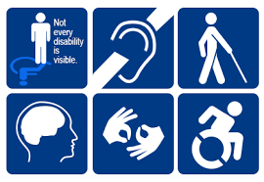
- who identifies as someone
- with disability (physical, sensory, intellectual, cognitive, etc.)
- who is Deaf / deaf / hard of hearing
- who lives with chronic illness, and / or pain
- who is neurodiverse, e.g. autistic, lives with ADHD, OCD, tics, learning disabilities, etc.
- who lives with mental health challenges.

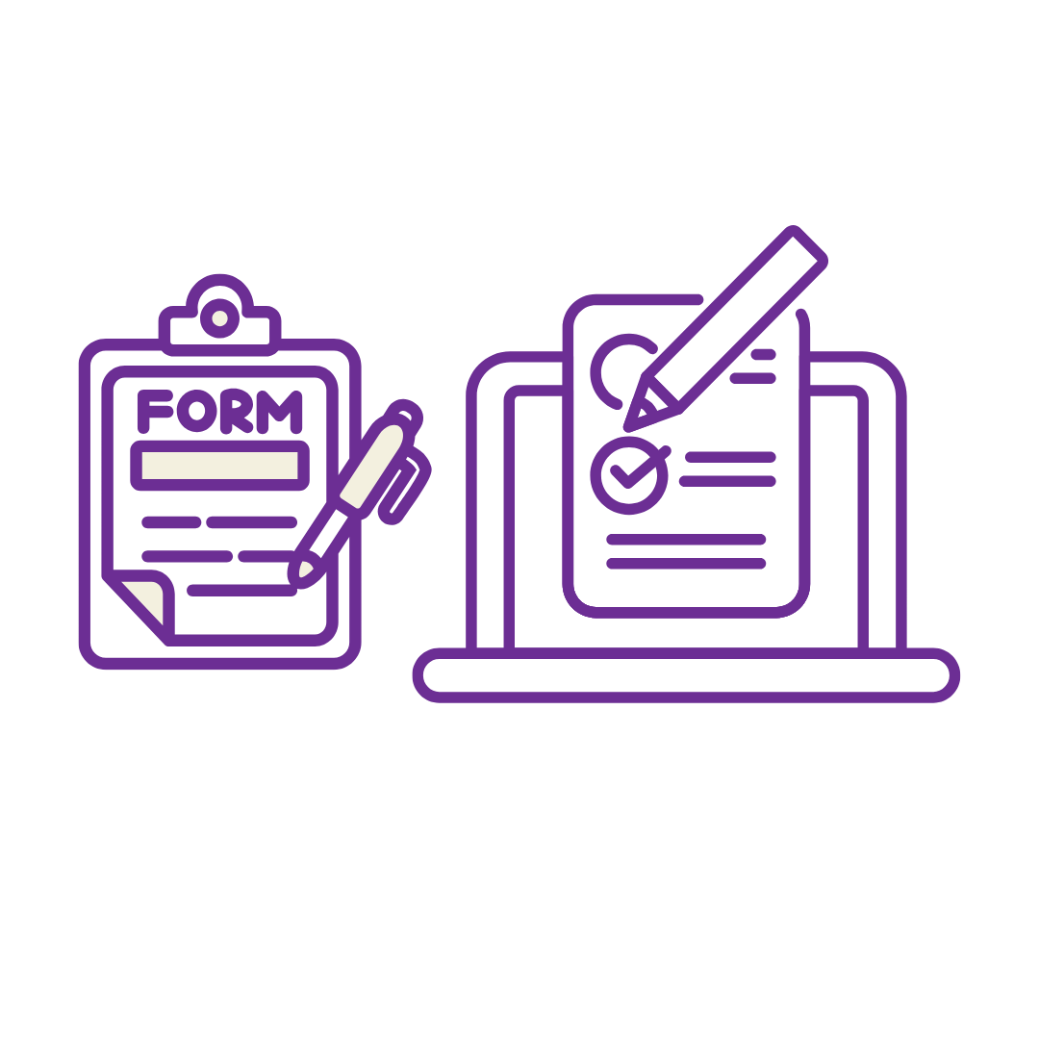
Completing the Application Form
To take part in the Enabling Women Leadership Program, you will need to fill out this Application Form.


If you want help:


You can ask someone you trust to help complete and send the form.

Or,
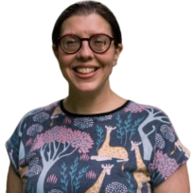
You can also contact Bridget at WDV to help you answer questions and fill in the form.

Email: leadership@wdv.org.au
Txt or Phone: 0459 322 479
You can fill out the form:
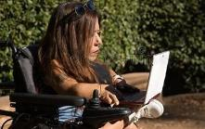
- On a computer, or


- By hand, or


- Record your answers in a video or audio recording.

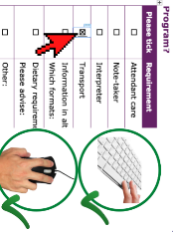

If you are using a computer to fill out the form, click the mouse or use the spacebar key to select check boxes.


Please email Bridget at WDV the completed form, or contact Bridget and let her know you have made a recording.

You can contact Bridget via email or phone.

Email: leadership@wdv.org.au
Phone: 0459 322 479

Application Form

Your Details
*Optional* = only answer if you want to
Our Question | Your Answer
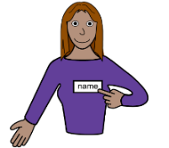
First and last name

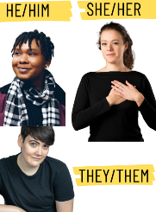  *Optional*  Pronouns | How should people refer to you? Examples “she”, “they”, “he”, or something else.

Year of birth


Street Address


Suburb
and
Postcode

Best contact phone number


Email address

  *Optional*  Do you speak a language other than English at home? | ☐ Yes – what language/s?  ☐ No
  *Optional*  Do you identify as Aboriginal and/or Torres  Strait Islander? | ☐ Yes – Aboriginal  ☐ Yes – Torres Strait Islander  ☐ No  ☐ Prefer not to say

Questions about you
Our Question | Your Answer
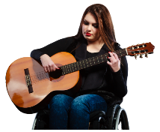
- What do you do for fun?


- Why do you want to do this Program?

  - Has anything stopped you from doing activities and other things you want to?  Particularly because of your gender or disability? | ☐ Yes  ☐ No  ☐ Not sure  If yes, what sort of things?
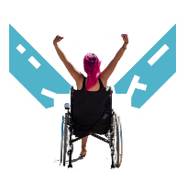  - Did you get through the problem?  If yes, how? | ☐ Yes  ☐ No  ☐ Not sure  If yes, how?
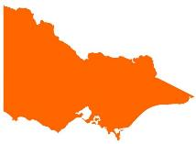  - What connection do you have with Victoria? | Examples, where you live, study, work, volunteer,or play.
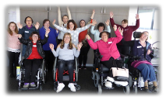  - Do you, or have you been part of any WDV programs or pojects? What ones? | Examples: Member events, Hubs, Workshops, etc.
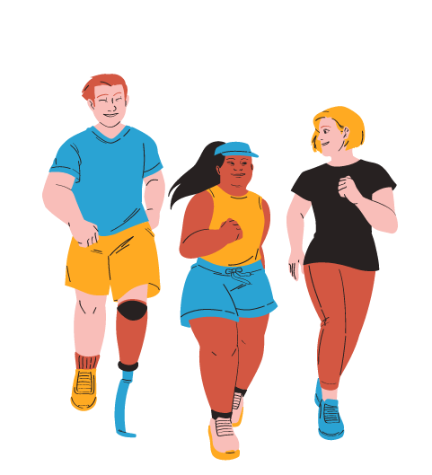  - What groups are you a part of now, or have been in the past? What do / did you do with these groups? | Examples: Peer group, committees, sporting club, Church, community groups. Etc.

- How did you hear about the Enabling Women Program?

Participation Questions
Our Question | Your Answer
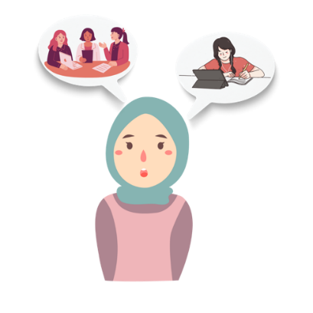  - Will you mostly participate in person or online? | ☐ In person  ☐ Online  ☐ It depends / unsure
  - Do you have a tablet or computer with internet at home? | ☐ Yes – computer  ☐ Yes – tablet  ☐ No
  - Does the internet work well? | ☐ Yes  ☐ No  ☐ Sometimes / Not sure
  - If you have a computer can you use these things with your computer? | ☐ Microphone  ☐ Headphones  ☐ Speaker  ☐ Webcam / camera

- If you think you may need extra help or equipment to join online, please give more information
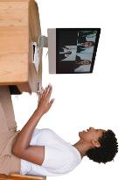  - Have you done an online video meeting before? | ☐ Yes - Zoom  ☐ Yes – Other. What did you use?  ☐ No
    - Would you like any help to use Zoom? | ☐ Yes – Please tell us in what ways?  ☐ No  ☐ Not sure
  8. If talking about uncomfortable topics, when do you feel most safe? | ☐ Participating online from home by myself  ☐ Being part of a friendly group setting in person  ☐ Not sure  ☐ Other / it depends

Access and Supports

The next three pages ask about access and supports.
Are there any access needs or supports that could help you to fully participate?
If you think you may need one of these supports, please tick the box and provide more information.

Our Question | Your Answer
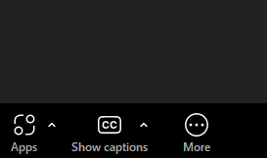  Captions | ☐ Yes - Tell us more: Automatic, live, or unsure.
  Interpreter | ☐ Yes - Tell us more:
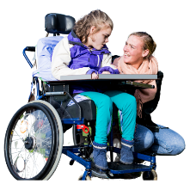  Attendant care | To help with eating, going to the bathroom, etc.  ☐ Yes - Tell us more:
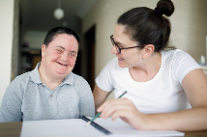  Note-taker | To help take notes of what’s said, your ideas, etc.  ☐ Yes - Tell us more:
  Wheelchair access | ☐ Yes
  Dog guide or service animal facilities | ☐ Yes - Tell us more:
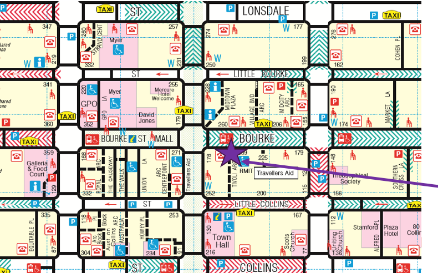  Transport / accessing the venue? | ☐ If yes, what requirements?
Information in other ways | Examples: Examples: Easy English, braille, audio, etc.  ☐ Yes - Tell us more:
  Dietary requirements | Examples: Vegan, Halal, or soft foods, etc.  ☐ Yes - Tell us more:
  Other  What else could help you to participate? | ☐ Yes - Tell us more:

If you have completed the application form on a computer, phone, tablet, or by hand,, please email Bridget at WDV your completed application form.
Email to leadership@wdv.org.au
This includes sending photos of your hand written form.

If you want help to fill out the form, or if you made a recording, you can email or call Bridget to discuss things further.

Email: leadership@wdv.org.au
Phone: 0459 322 479

Thank you for your application!

