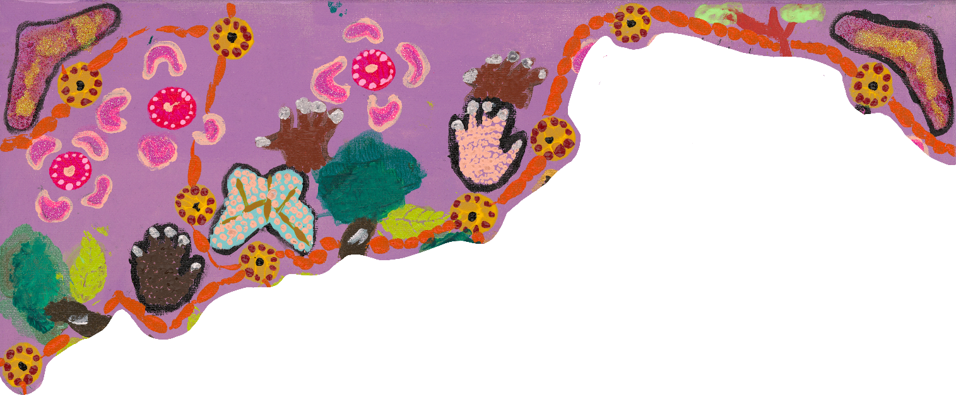

Women with Disabilities Victoria

Reflect

Reconciliation Action Plan

July 2024 – June 2025

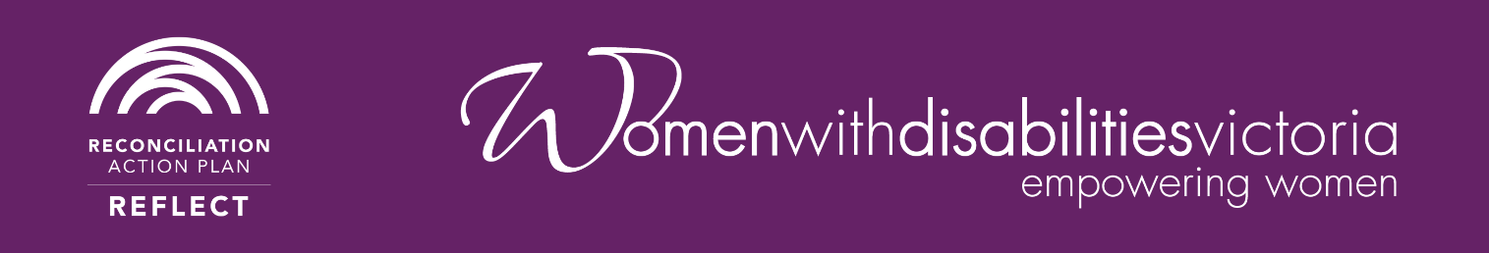

Acknowledgement of Country
Women with Disabilities Victoria (WDV) respectfully acknowledges Aboriginal people as the Traditional Custodians of the lands and waters on which we work, rest, and continue to benefit from. We pay our respects to the Elders, past and present, of Aboriginal and Torres Strait Islander Communities across Victoria and acknowledge that their continued strength and resilience is built upon more than 60,000 years of history. The WDV community is committed to honouring the unique cultural and spiritual relationship Aboriginal and Torres Strait Islander peoples have with the land and waters, and their rich contribution to society.
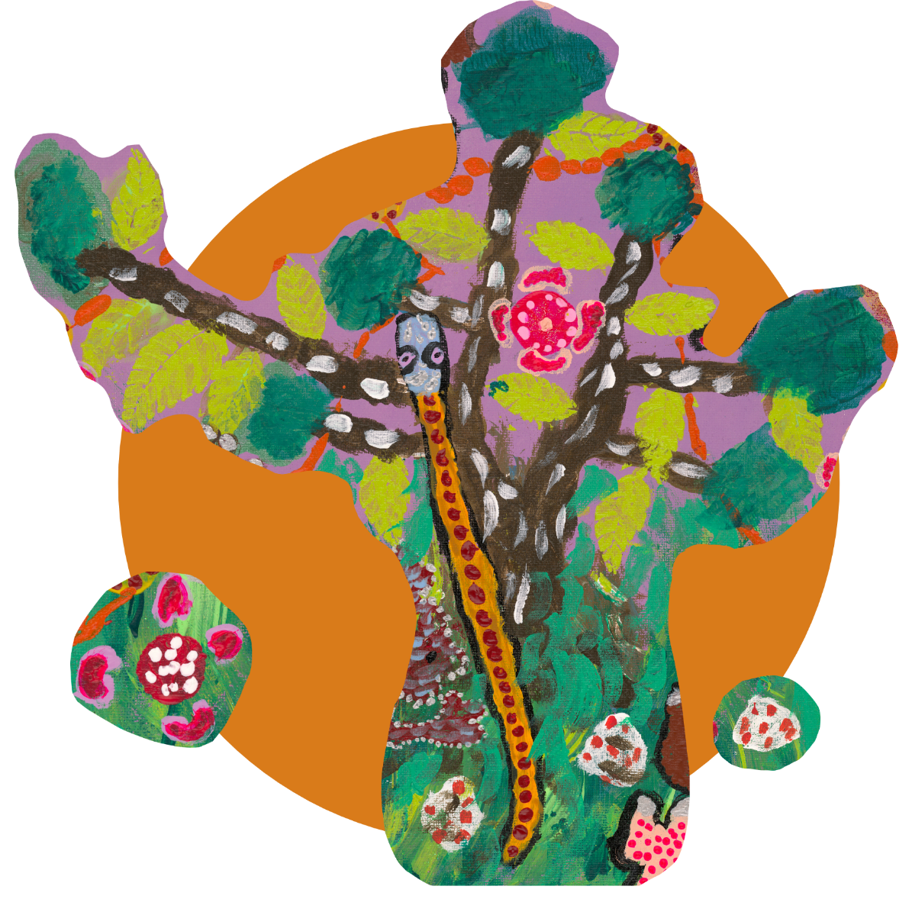

Contents
Acknowledgement of Country 1
Contents 2
The Artist 3
Acknowledgement of the Artist - Aunty Jane Rosengrave 3
The Artwork 4
About the Artwork 5
About Us 7
Our Business 8
Our RAP 11
Accessibility 12
Our Partnerships/Current Activities 13
Relationships 15
Respect 18
Opportunities 21
Governance 23

The Artist

Acknowledgement of the Artist - Aunty Jane Rosengrave
Proud Yorta Yorta woman Aunty Jane Rosengrave is a disability advocate and artist. Jane has an intellectual disability and is a fierce self-advocate and champion for others. Experiencing institutionalisation and abuse from a very young age Jane was kept from her culture and communities. She endured an abusive relationship and further disconnection for many years. But happily, Jane is free as a bird now.
Once kept from her Aboriginal culture, Jane now thrives within it. Jane is a proud Aunty in her community. Once denied the pride of being a part of the disabled community, Jane is now a leader, empowering others.
Jane is a WDV member and has worked on projects that address violence against women with disability. She bravely uses her story to support others, so they can be free as a bird one day too.
Jane has often appeared in the media and her strong advocacy has been shared with self-advocates across the country through workshops and training. In 2016 Jane joined the First Peoples Disability Network (FPDN) Board and is also on the Board at People with Disability Australia (PWDA). Jane was awarded the Tony Fitzgerald Memorial Award at the Australian Human Rights Awards 2016.
Regaining her connection with Country and culture, Jane now shows her identities, proudly. Her tattoos; a turtle, based on her tribe — Yorta Yorta and an Aboriginal flag worn with pride. Alongside them what has become Jane’s life motto, a ‘free as a bird’ tattoo. Storytelling through art has always been a part of Jane. Even when her culture was denied, deep down she knew the spirit was always within her. Jane’s painting is for the generations and for her communities. Her art connects her, it shows people who she is and what is important to her.

The Artwork
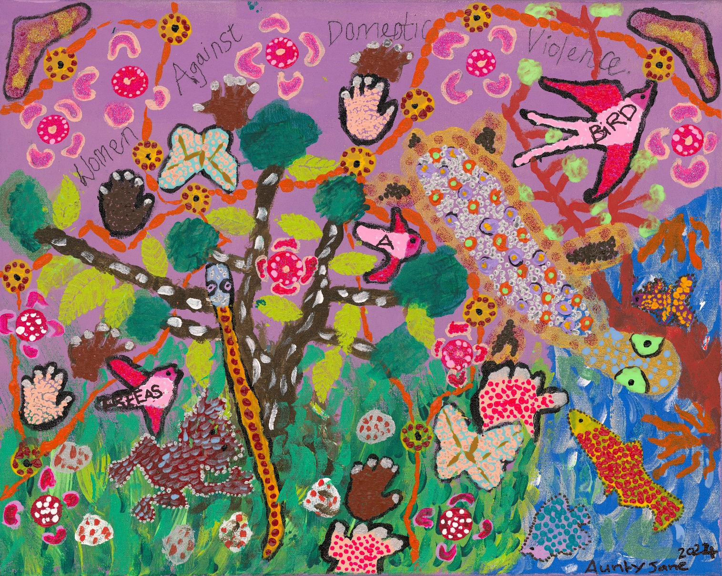

About the Artwork
Aunty Jane’s painting has natural and abstract features. The colours are vibrant and the brush strokes and dots of paint are textured on the canvas. There is a blue sea/river in the bottom right corner with a turtle and fish. An orange-coloured tree grows near it. To the left of the sea is green grass and a black tree with white dashes. The background of the painting is lilac. There is a frog and a snake in the grass area. There are birds and butterflies across the painting. The birds have the words “Free as a bird” written on them. There is a boomerang in the top right and left corners. There are hand shapes across the painting. The words “Women against domestic violence” is written across the top third of the painting. There is an orange line intersected by yellow and brown circles. There are ten pink circles with boomerang shapes around them. Please see Aunty Jane’s detailed description below for more.
“My name is Aunty Jane and I'd like to begin by paying my respects to the Aunties, Uncles, mums, dads, nieces, nephews, brothers and sisters, grandmas and grandpas and to the traditional custodians of this land on where we are meeting today, its Elders past and present, and the self-advocacy people who have passed away and who are still here today on Aboriginal land.
Now the painting, this is the sea with the fish in it (bottom right of painting where there is a blue and silver sea) and green weeds in it as well, and some of the white sand that's in it. This is a long neck turtle, my tribe Yorta Yorta (light brown turtle with lilac, orange and green spots on its back, blue dots on its head and green eyes). And this is the orange tree growing in the river or in the sea with the leaves of the tree, the green trees, the branches on there. And this is the red dirt, the red dust with the Aboriginal organisations that are here in the background (a dashed line in orange with 12 intermittent yellow circles with reddy brown dots in them), and the boomerang here (a boomerang with a black outline, purple sparkles and gold sparkles in it). And these are the ladies (pink circles with pale pink dots in them surrounded by 4 pink boomerang shapes) that are talking about their domestic violence and other problems or health problems, and money wise, you know what they're going through sitting in a circle here the on the grass (dark and light green grass at the bottom left of the painting).
And these are the birds (three dark and light pink birds that are flying from the bottom left to top right of the painting that have the words on them) that are going from domestic violence saying ‘free as a bird’ after what they've been through as well. These are the hands. These are for the white people (two hands made up of pale beige dots), and these ones are for the Aboriginal people (two hands made of dark brown dots). And these are the rocks (white circles with dark pink dots in them), and the frog (a dark brown frog with blue dots in the middle and a white dot outline), and the nut and the grass and the leaves that are on the tree as well (light green leaf shapes on a black tree shape with white dashes along the trunk and branches). And the butterflies that are flying away saying I'm as free as a bird as well after I've been through domestic violence” (two pale blue butterflies with pale pink dots and gold intersecting lines on them).
Click here for a video of Aunty Jane describing her artwork: https://youtu.be/70Y9ZG9qEEg

About Us
Women with Disabilities Victoria (WDV) is a state-based, not-for-profit Disabled Peoples Organisation (DPO). We are run for and by women and non-binary people with all kinds of disabilities. Our members are people of all ages, backgrounds and lifestyles.
As a community organisation, we recognise that we are all responsible for strengthening the relationships of Aboriginal and Torres Strait Islander peoples and non-Indigenous people in the process towards reconciliation.
We are very excited to be commencing our reconciliation journey with the development and implementation of our first Reconciliation Action Plan (RAP).
A RAP is both a process and a document that provides a framework for organisations to support the national reconciliation movement. At this stage, we are in the Reflect phase of our reconciliation journey and we are working towards cementing the foundations for building relationships, respect and identifying opportunities.
Our RAP is endorsed by our Board and Leadership team and championed by our Chief Executive Officer (CEO).
“WDV’s Reflect RAP will lay the foundations for our commitment to our reconciliation journey”, says Nadia Mattiazzo, WDV CEO.
The RAP will highlight: Relationships, Respect, Opportunities, and Governance. As with all our work, our intention is to develop a RAP that is gender and disability inclusive and accessible.

Our Business
As a peak Victorian body, WDV's work addresses the intersections of gender and disability.
In 1992, after feeling repeatedly ignored and marginalised by multiple political movements, a small group of women with disabilities came together to ‘do something’. Our organisation slowly, but steadily, grew from there.
WDV is now working towards a contemporary understanding of gender and gender inclusivity in our work and our values.
Our purpose, to empower all women with disabilities in Victoria.
WDV’s vision is a world where all women are respected and can fully experience life. Our mission is to advance real social and economic inclusion for women with disabilities in Victoria. We pursue these by amplifying voices for our community, creating opportunities to be visible and to be heard in mainstream settings, by building partnerships to deliver the best results and engaging the community to challenge attitudes and myths.

Our values are:
- equal opportunity,
- accessibility,
- respect,
- collaboration,
- effectiveness,
- creativity,
- diversity, and
- accountability.

WDV’s central functions involve:
- providing systemic support, advocacy, and resources to women and non-binary people with disabilities in leadership roles,
- working with community services and organisations to ensure inclusion of women and non-binary people with disabilities,
- ensuring disability services consider a gender perspective that is responsive to women and non-binary people with disabilities,
- working in partnership with other disability and women’s organisations,
- encouraging and undertaking research on issues affecting women and non-binary people with disabilities,
- providing a voice for women and non-binary people with disabilities to influence government policy and legislation.

We are governed by a voluntary board and are financially supported through government agencies, associate members, community partners and philanthropy. As a DPO, our board co-chairs, CEO, and other leadership positions are held by women and non-binary people with lived experience of disability.
Our membership is free to all women and non-binary people living with disabilities in Victoria, with a diverse and growing membership. We have over 900 full members, and 50 associate individual and organisational members. Of our current membership, there are 17 full members who have voluntarily identified as Aboriginal and Torres Strait Islander people.
WDV employs approximately 28 contracted staff and 18 casual staff. No staff member has identified as Aboriginal or Torres Strait Islander, however we have one staff member who identifies as a First Nations person from Aotearoa (New Zealand).
We operate within the state of Victoria, delivering online, in-person and hybrid programs and events. Our main office is in the city of Naarm (Melbourne) on Wurundjeri land. Our five community hubs are in Djilang of the Wadawurrung People (Barwon region), Yarrawonga of the Yorta Yorta People (Moira region), lands of the Dja Dja Wurrung and Taungurung Peoples (Bendigo), lands of the Wurundjeri People (Melbourne Outer East) and Warnimble of the Gunditjmara People (Warrnambool).

Our RAP
WDV is an intersectional feminist organisation that has a strong sense of solidarity with First Nations people. We share a desire for self-determination and recognise the ongoing impact of colonisation as a contributing factor to the violence experienced by First Nations women and non-binary people with disabilities. Developing a RAP is a way for us to formalise our support and shift our intentions into actions.
As part of WDV’s emphasis on accessibility and inclusion, it felt important for us to consult our lived experience experts and include our members in the process of developing the RAP. In a recent members survey, the rights of First Nations women with disabilities were identified as a priority by a significant number of the respondents. A strong interest in training and learning about ways to be culturally respectful has surfaced in our staff, board and members. Our Reflect RAP will ensure these needs are met so we can become an organisation that is mob friendly and inclusive.
Evidence shows that the experience of disability in Aboriginal and Torres Strait Islander people are disproportionately high compared to the non-Indigenous populations. By engaging in the RAP process, WDV looks forward to further educating ourselves and developing meaningful relationships with Aboriginal Community Controlled Organisations (ACCOs).
WDV formed a Reconciliation Action Plan Working Group (Working Group) on the 7th of March 2023, with nine attendees. The Working Group has met regularly, meeting ten times between March and November 2023.
WDV’s RAP Champion is Nadia Mattiazzo, WDV CEO.
In May 2023, we had a staff day at Melbourne Zoo where the Working Group presented to all staff. This presentation included; what is a RAP, why now, where are we up to, and how to get involved.
Members of the Working Group held two consultations with WDV lived experience experts in July and September. These consultations provided us with valuable insights into how we created our RAP and how to ensure accessibility.

Accessibility
As an organisation run by and for women and non-binary people with disabilities - we are committed to making our activities and resources inclusive and accessible. We aim to make our RAP processes accessible to WDV staff and members, many who have a variety of communication methods and needs. This includes consultation with our community and lived experience workforce.
We will produce our Reflect RAP in multiple accessible formats to meet the access needs and reflect the diversity of our community. Making our RAP document accessible includes providing formats such as a Plain English/Easy English document as well as a text only Word document that suits screen reading softwares. This can create greater access across the community for people with intellectual disabilities, learning disabilities, print disabilities, people from Culturally and Linguistically Diverse (CALD) or Culturally and Racially Marginalised (CARM) backgrounds, and those who are neurodivergent. WDV hopes that by providing these different formats that it will normalise providing documents that are inclusive and accessible as part of equitable practice.

Our Partnerships/Current Activities
It is standard practice across WDV to begin events, training sessions and external meetings with an Acknowledgement of Country. Our staff present the acknowledgement and invite participants to acknowledge the land they are on during the meeting if meeting online. Key organisational documents also include an Acknowledgement of Country.
At featured events, WDV has engaged with local First Nations groups for official Welcome to Country. These have been collectively celebrated and is an area we look forward to expanding on with future WDV events.
As an organisation, WDV provides the option for staff to swap the public holiday on January 26 for National Close the Gap Day or Mabo Day.
As of 2023, WDV staff and leadership have undertaken a variety of learning around Aboriginal and Torres Strait Islander histories and cultures. This has included research and engagement both independently and as groups by staff and the Board. The board and some staff have also undertaken Cultural Safety Training.
WDV staff and teams actively support and attend events hosted by ACCOs and create opportunities to share, celebrate and platform Indigenous women and non-binary people with disabilities’ voices in their communities.
WDV acknowledges National Reconciliation Week and NAIDOC Week as important opportunities to elevate First Nations voices throughout our community and our work. Staff are encouraged to engage in local activities and reflect on the meaning of these events individually and within their teams. WDV’s Communications team re-posts from relevant ACCOs on our social media accounts to promote reconciliation among our members and stakeholders.
While we have partnerships with a range of ACCOs and some positive connections with Aboriginal and Torres Strait Islander community groups, we are committed to strengthening these relationships. WDV is committed to continuing building meaningful engagements with First Nations women and non-binary people with disabilities in Victoria.
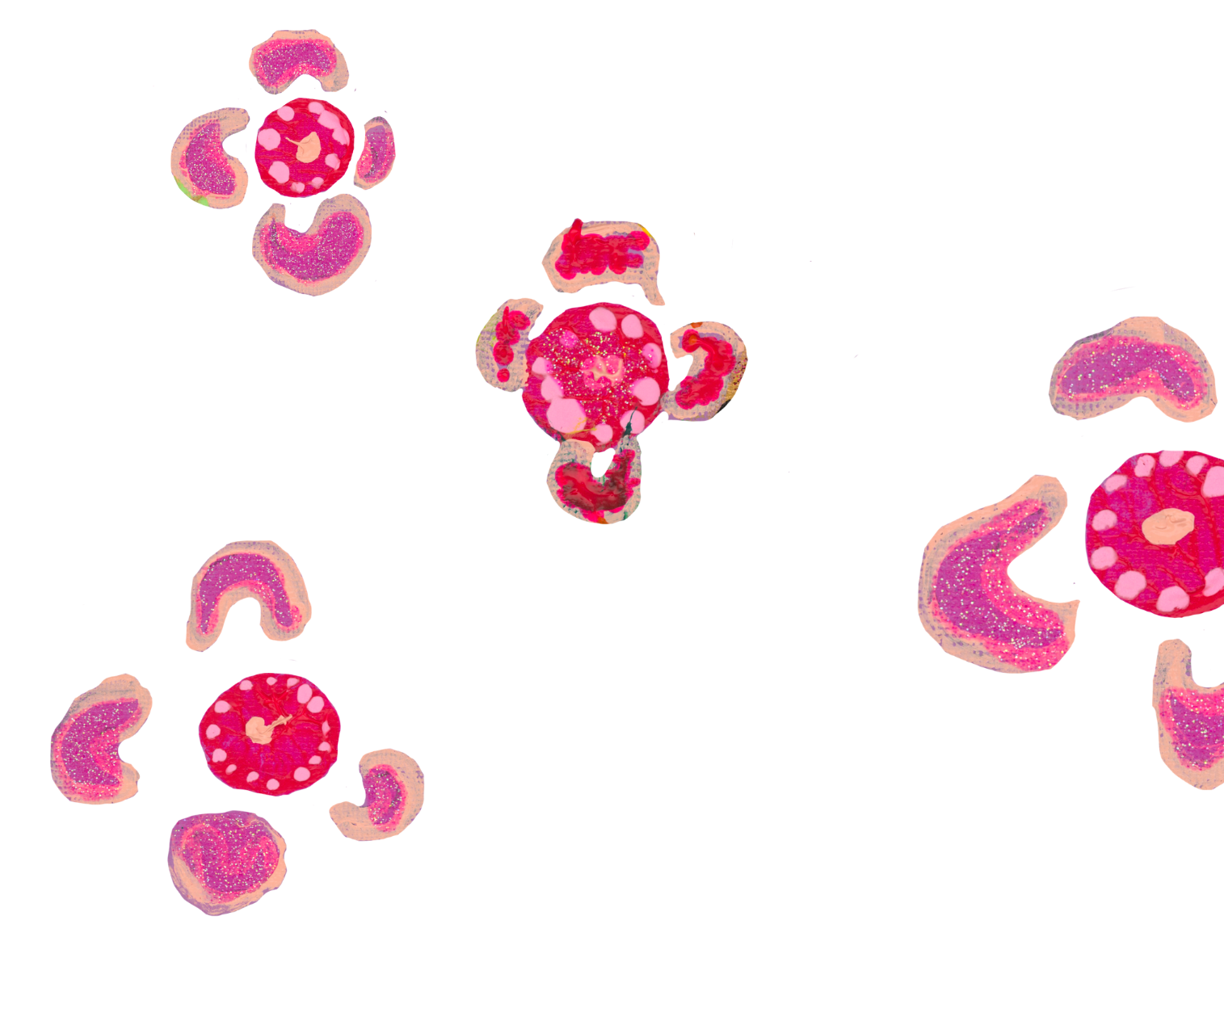

Relationships
Actions
- Establish and strengthen mutually beneficial relationships with Aboriginal and Torres Strait Islander stakeholders and organisations.
  - Deliverable: Identify Aboriginal and Torres Strait Islander businesses and organisations in our local area or sphere of influence.
    - Timeline: June 2024
    - Responsibility: CEO
  - Deliverable: Research best practice and principles that support partnerships with Aboriginal and Torres Strait Islander stakeholders and organisations.
    - Timeline: June 2024
    - Responsibility: CEO

- Build relationships through celebrating National Reconciliation Week (NRW).
  - Deliverable: Circulate Reconciliation Australia’s NRW resources and reconciliation materials to our staff.
    - Timeline: May 2024
    - Responsibility: Director Business Operations
  - Deliverable: RAP Working Group members to identify suitable local NRW events and participate in NRW.
    - Timeline: 27 May – 3 June 2024
    - Responsibility: CEO
  - Deliverable: Encourage all staff to participate in at least one external event to recognise and celebrate NRW.
    - Timeline: 27 May – 3 June 2024
    - Responsibility: CEO
  - Deliverable: Communicate the significance of NRW at staff meetings and in eNews.
    - Timeline: May 2024
    - Responsibility: CEO

- Promote reconciliation through our sphere of influence
  - Deliverable: Identify RAP and other like-minded organisations that we could approach to collaborate with on our reconciliation journey.
    - Timeline: June 2024
    - Responsibility: Director Business Operations
  - Deliverable: Communicate our commitment to reconciliation to all staff.
    - Timeline: April 2024
    - Responsibility: CEO
  - Deliverable: Identify external stakeholders that WDV can engage and collaborate with on our reconciliation journey.
    - Timeline: June 2024
    - Responsibility: CEO

- Promote positive race relations through anti-discrimination strategies.
  - Deliverable: Research best practice and policies in areas of race relations and anti-discrimination.
    - Timeline: June 2024
    - Responsibility: Director Policy, Advocacy & Community Engagement
  - Deliverable: Conduct a review of HR policies and procedures to identify existing anti-discrimination provisions, and future needs.
    - Timeline: June 2024
    - Responsibility: Director Business Operations with the HR Manager
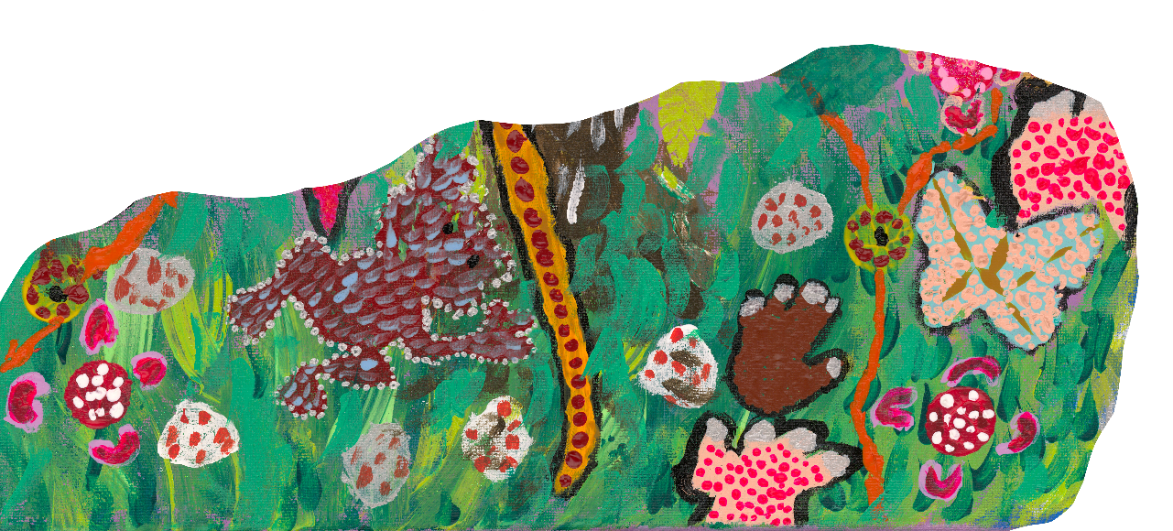


Respect
Actions:
- Increase understanding, value and recognition of Aboriginal and Torres Strait Islander cultures, histories, knowledge and rights through cultural learning.
  - Deliverable: Review options for cultural learning needs at WDV.
    - Timeline: April 2024
    - Responsibility: CEO
  - Deliverable: Develop a business case for increasing understanding, value and recognition of Aboriginal and Torres Strait Islander cultures, histories, knowledge and rights being met within our organisation.
    - Timeline: June 2024
    - Responsibility: CEO
  - Deliverable: Develop a learning plan (based on the outcome of the above deliverable) for all staff. Include cultural competency activities such as truth telling workshops, that increase WDV’s understanding, value and recognition of Aboriginal and Torres Strait Islander cultures, histories, knowledge, and rights being met.
    - Timeline: August 2024
    - Responsibility: CEO

- Demonstrate respect to Aboriginal and Torres Strait Islander peoples by observing cultural protocols.
  - Deliverable: Identify opportunities to increase organisational knowledge and understanding of the cultural significance of Aboriginal and Torres Strait Islander peoples and their cultural protocols.
    - Timeline: September 2024
    - Responsibility: CEO.
  - Deliverable: Develop an understanding of the local Traditional Owners or Custodians of the lands and waters within our organisation’s operational area.
    - Timeline: December 2024
    - Responsibility: CEO
  - Deliverable: Explore ways to Accessify (meaning to make resources and environments accessible and available in various accessible formats) observing cultural protocols that are culturally safe and relevant. Collaborate with other organisations who are engaging in similar initiatives.
    - Timeline: November 2024
    - Responsibility: Health Services Program Manager

- Build respect for Aboriginal and Torres Strait Islander cultures and histories by celebrating NAIDOC Week
  - Deliverable: Engage in organisational learning to increase knowledge and understanding of NAIDOC Week.
    - Timeline: June 2024
    - Responsibility: CEO
  - Deliverable: Promote NAIDOC events across Victoria.
    - Timeline: June 2024
    - Responsibility: Marketing Co-ordinator
  - Deliverable: RAP Working Group to participate in an external NAIDOC week event.
    - Timeline: First week in July 2024
    - Responsibility: Marketing Co-ordinator

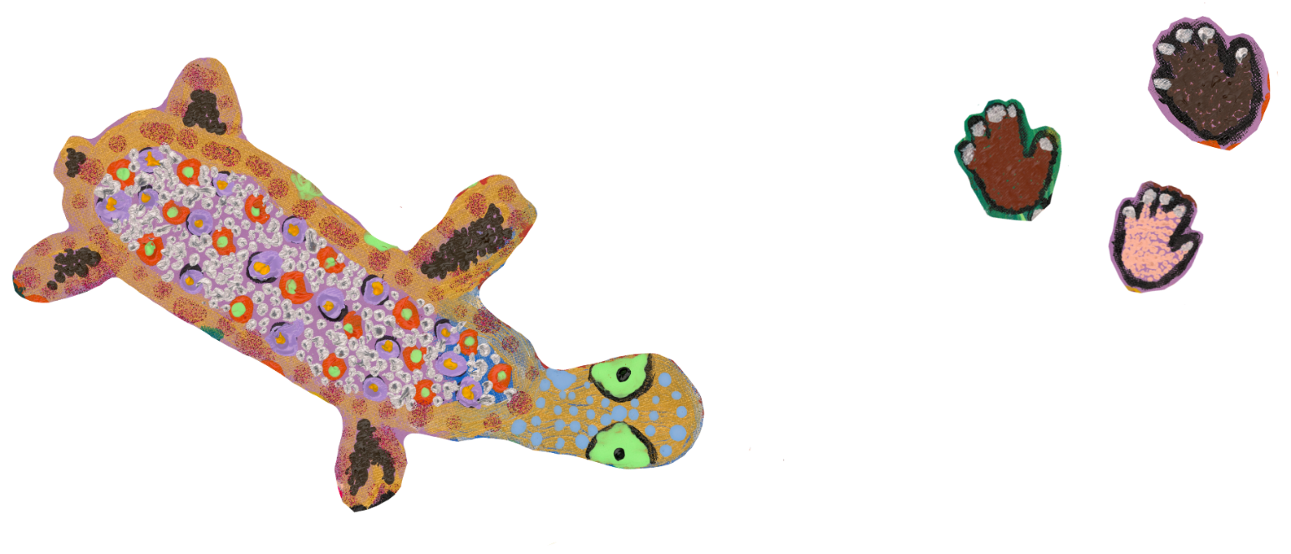


Opportunities
Actions:
- Improve employment outcomes by increasing Aboriginal and Torres Strait Islander recruitment, retention, and professional development with a strong emphasis on First Nations women and non-binary people with disabilities.
  - Deliverable: Our organisation recognises the importance of diversity and inclusion. We will aim to develop a business case that strengthens the employment opportunities for Aboriginal and Torres Strait Islander people with disabilities.
    - Timeline: October 2024
    - Responsibility: Director Business Operations
  - Deliverable: To build understanding of current Aboriginal and Torres Strait Islander staffing to inform future employment and professional development opportunities.
    - Timeline: October 2024
    - Responsibility: Director Business Operations

- Increase Aboriginal and Torres Strait Islander supplier diversity to support improved economic and social outcomes.
  - Deliverable: Investigate Supply Nation membership.
    - Timeline: June 2024
    - Responsibility: Director Business Operations
  - Deliverable: Develop a business case for procurement from Aboriginal and Torres Strait Islander owned businesses.
    - Timeline: June 2024
    - Responsibility: Director Business Operations

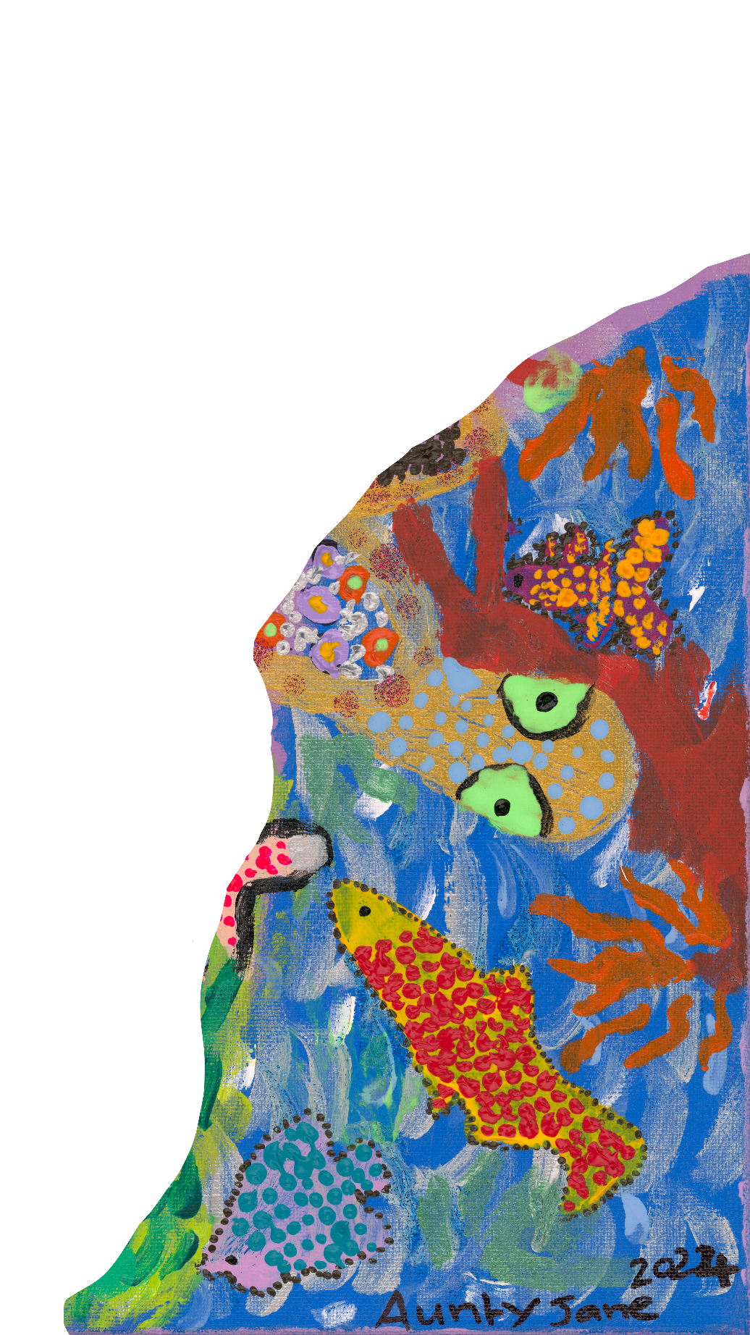



Governance
Actions:
- Establish and maintain an effective RAP Working Group to drive governance of the RAP.
  - Deliverable: Maintain an effective RAP Working Group to govern RAP implementation and promote the aims of the RAP across WDV.
    - Timeline: December 2024
    - Responsibility: CEO
  - Deliverable: Review the Terms of Reference for the RAP Working Group.
    - Timeline: December 2024
    - Responsibility: Director Business Operations
  - Deliverable: Schedule RAP Working Group meetings regularly to coordinate on RAP implementation.
    - Timeline: December 2024
    - Responsibility: Director Business Operations
  - Deliverable: Establish Aboriginal and Torres Strait Islander representation on the RAP Working Group.
    - Timeline: October 2024
    - Responsibility: CEO

- Provide appropriate support for effective implementation of RAP commitments.
  - Deliverables: Define resourcing needs for RAP implementation
    - Timeline: July 2024
    - Responsibility: CEO
  - Deliverable: Engage senior leaders in the delivery of RAP commitments including the WDV Board.
    - Timeline: August 2024
    - Responsibility: CEO
  - Deliverable: Define appropriate systems and capability to track, measure and report on RAP commitments.
    - Timeline: March 2024
    - Responsibility: Director Business Operations
  - Deliverable: Maintain a senior leader to champion our RAP internally.
    - Timeline: Review December 2024
    - Responsibility: CEO

- Build accountability and transparency through reporting RAP achievements, challenges and learnings both internally and externally.
  - Deliverable: Contact Reconciliation Australia to verify that our primary and secondary contact details are up to date, to ensure we do not miss out on important RAP correspondence.
    - Timeline: June 2024
    - Responsibility: Director Business Operations
  - Deliverable: Report annually on RAP actions in the annual report and at the AGM.
    - Timeline: 2024 Annual Report (October 2024) and 2024 AGM (November 2024)
    - Responsibility: CEO
  - Deliverable: Contact Reconciliation Australia to request our unique link to access the online RAP Impact Survey.
    - Timeline: 1 August annually
    - Responsibility: Director Business Operations
  - Deliverable: Complete and submit the annual RAP Impact Survey for 2023/24 to Reconciliation Australia.
    - Timeline: 30 September annually (Latest submission date)
    - Responsibility: CEO

- Continue our reconciliation journey by developing our next RAP.
  - Deliverable: Register via Reconciliation Australia’s website to begin developing our next RAP.
    - Timeline: November 2024
    - Responsibility: Belinda Burns, Director of Business Operations

Contact
Belinda Burns
Director of Business Operations
Belinda.burns@wdv.org.au

Throughout this document we use the terms women and non-binary people with disability. We understand the word women to include cisgender and transgender women. We understand non-binary to include those who are gender diverse, gender non-confirming or other identifiers that our members may use.
WDV is now working towards a contemporary understanding of gender and gender inclusivity in our work and our values.

