TEN YEARS – A CELELBRATION OF THE ENABLING WOMEN LEADERSHIP PROGRAM

Acknowledgement of Country

Women with Disabilities Victoria acknowledges the traditional owners and custodians of the lands on which WDV works and where the Enabling Women Leadership Programs have taken place over the years.

WDV recognises the history, culture, diversity and value of all Aboriginal and Torres Strait Islander people and pay our respects to their Elders past and present.

In memoriam

WDV acknowledges that sovereignty has never been ceded, and supports reconciliation, justice and the recognition of the ongoing living culture of all Aboriginal and Torres Strait Islander people.

We acknowledge that over the years we have lost members of the Enabling Women community. We honour their memories in these words, pictures and legacy of the Program.

Language in context

The ways we think about disability and gender change and evolve over time. WDV emerged to resist ableism and the structures, culture and services that were designed for and privilege the needs of cis-gendered men. In carrying forward this history, our language is evolving.

We are committed to developing an inclusive approach that is relevant to and reflects transgender and non-binary experiences. Please be aware that some of the language or ideas about disability and gender used in earlier Programs are outdated and no longer used.

Foreword

People say you are attracted to jobs that you can learn from. In 2013, my new job was to help realise the ground work laid down by WDV and a designated working committee - to empower women with disabilities through the development of a leadership program.

I am thankful for the opportunity I had to work at WDV, to learn and share with so many people connected to the Enabling Women program. And ten years on, to be able to reflect on and celebrate the achievements of everyone involved.

For each program, it was so lovely to see the women connect, discuss their experiences, try new things, and find ways to be leaders in their communities.

Setting up and running programs within all the different places takes a lot of local knowledge and resources. The role of reference groups and community supporters, particularly in the early days of the Program, cannot be understated.

The focus of community connections and impact is strong, Enabling Women is a program that meets participants where their lives are at. It encourages exploration of gender and disability, and for members to find their own version of leadership.

With our history often being trampled on, and women with disabilities unseen and unheard, when I think of highlights of the Program, it’s often the moments where community connections were made and the confidence of women with disabilities blossomed.

I’ve seen the continued development of Enabling Women, and how the Program has stayed current with the evolution of topics covered in its early days - even if we didn’t use the same terms as is used now.

Ideas of intersectionality, models of disability, and disability pride. These themes are present in many of the activities and resources that Enabling Women has used, including those from around the world. And that as women with disabilities, we are LOUD, PROUD, PASSIONATE leaders.

Jane Oldfield, Enabling Women Facilitator and Women’s Empowerment Officer, Women with Disabilities Victoria, 2013-2019.

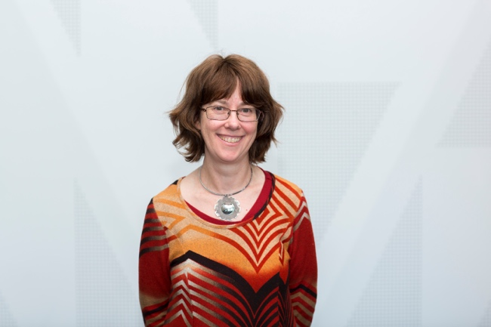
Image Description: Photo of Jane Oldfield smiling.

Messages from the team

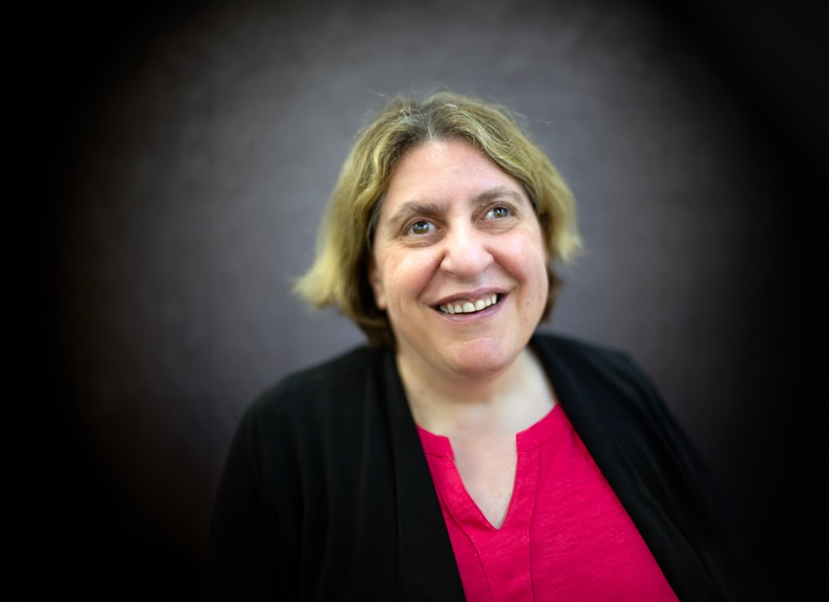

“I’m really proud of the achievements of the Enabling Women Leadership Program...I think that it has achieved some incredible things in the last ten years and I’m really excited to see what the Program will achieve in the future.”

Nadia Mattiazzo
CEO, Women with Disabilities Victoria.

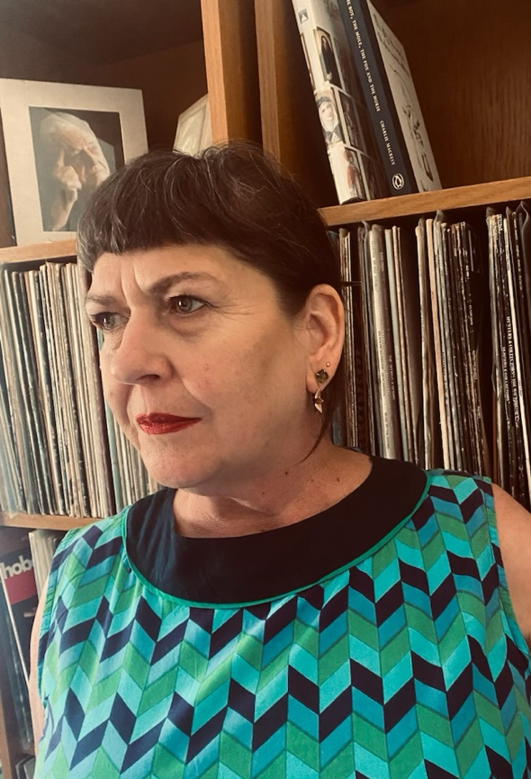

“Over the ten years I’ve worked with women who’ve been through the Program, I’ve been on committees with women who’ve been through the Program, and to see the growth of each individual person in their own way has been extraordinary. And it’s not just a little course, it’s a life changing program.”

Liz Wright
Manager of Community Inclusion and Women’s Empowerment.

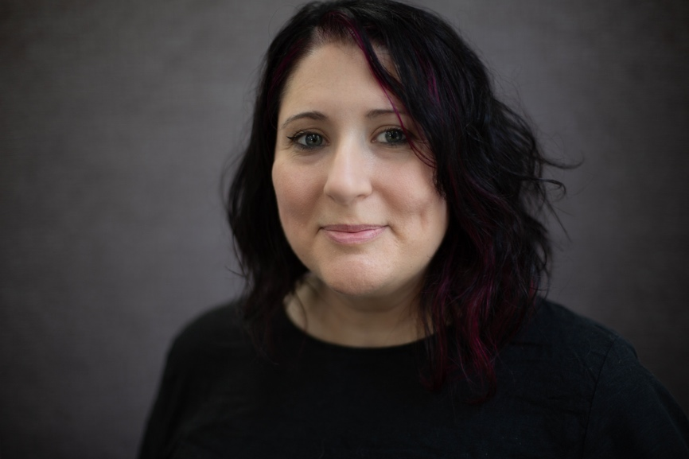

“Let’s get people, you know, passionate about wanting to have a more inclusive, interesting, diverse community...with empowered women and non-binary people with disability.”

Brigitte Stone
Women’s Empowerment Officer.

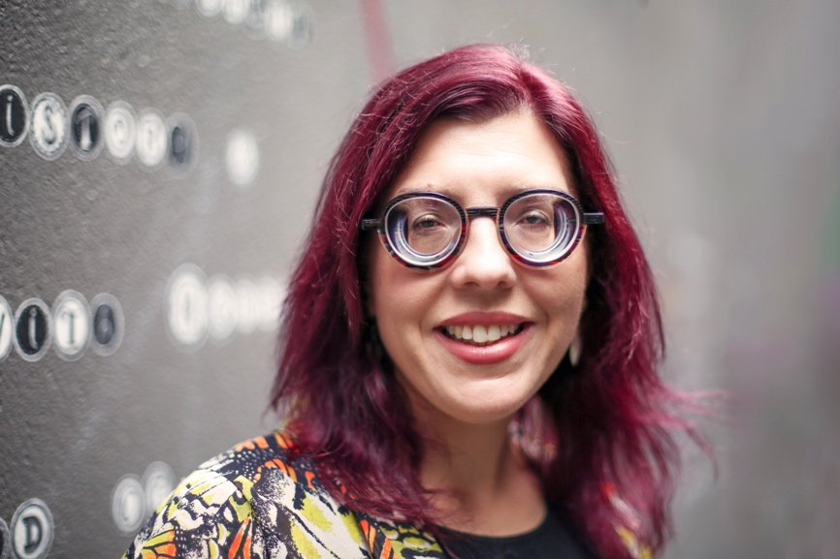

“My hope for the future is that we’re able to continue running programs and actually a lot more of them, and in particular in regional and rural areas. So really wanting to make sure that we are giving as many people as possible the opportunity to become leaders.”

Bridget Jolley
Women’s Empowerment Officer, Youth.

Introduction

Women with disabilities can’t be ignored. That was the statement, the mission, the irrefutable truth that connected a group of Victorian women with disability in the early nineties.

Bringing together experienced trailblazers and emerging leaders, the Victorian Women with Disabilities Network (VWDN) was informal but undeniably passionate.

Regular meetings to discuss the issues they faced lead to strategies on how to advance the interests of women with disability across the state. By 2010 the network was incorporated. Rebranded as Women with Disabilities Victoria, VWDN became WDV. Bolstered with ongoing funding the focus could better be put on making real and lasting change.

Finally, women with disabilities across Victoria had an organisation reflective of their experiences, dedicated to improving their social and economic participation through policy, research and advocacy.

Now a not-for-profit association managed by a Board of Directors, WDV has persisted to grow from its first four members of staff to now employing 50 staff, including experts and casuals, the vast majority of them identifying as women and non-binary people with disability.

Elevating the voices of WDV’s diverse and growing constituency remains vital to the organisation.

Members are still encouraged to be deeply involved in the discussions that impact their lives and to believe in the value of their experiences to influence positive change.

WDV’s origins lay in those early days, a network empowering women with disabilities to learn about their rights and find strength in unity.

These enabled women transformed a network into an organisation. A workforce of empowered and passionate leaders advocating and supporting opportunities for Victorian women and non-binary people with disabilities.

Paying homage to the early days, where ideas of leadership were central to the realisation of self-advocacy, WDV successfully campaigned for funded projects that explored leadership. The impact of disability and gender on leadership was clear. The double disadvantage that arises from that intersection was irrefutable.

WDV’s mission to support women with disabilities to be leaders in their communities and beyond was set and a new mantra found: ‘Women and girls with disabilities are the solution, not the problem.’

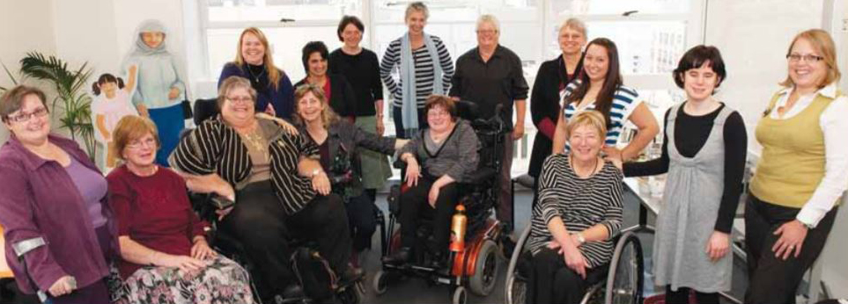
Image description: Original members of the Victorian Women with Disabilities Network. The women are in a group smiling at the camera.

Enabled Women

The revolutionary act of bringing together women and non-binary people with all kinds of disabilities to share their varied experiences, to learn about their rights, advocacy and leadership, echoes in the creation of the Enabling Women Program.

A strategic direction to promote leadership opportunities for women with disabilities and foster their empowerment and participation lead to the Program’s inception. The Program was developed in direct response to the disproportionate exclusion of women with disabilities from employment, higher education, secure accommodation as well as increased exposure to physical, sexual and family violence. Importantly, the Program acknowledged the further disadvantage experienced by women with disabilities in regional and rural Victoria. Iterations of the Program have also homed in on other impacting intersections, such as youth and people from Culturally and Linguistically Diverse (CALD) backgrounds.

With every delivery, the Program is tailored and refined to best support participants to build individual capacity – to learn about their rights, the importance of speaking up and how to be a leader. Refuting the tired and constant messaging where women and non-binary people with disabilities are marginalised and systematically denied their human rights, the Enabling Women Leadership Program empowers participants with the knowledge their rights matter. That they matter. That they have the right to be healthy, free of violence and to participate fully in life.

At its heart Women with Disabilities Victoria was created by members who sought ‘to empower and support women with disabilities in Victoria to achieve their rights in the disability movement, the women’s movement and society in general by the provision of communication, information sharing, networking, advocacy, peer support and education’.

For ten years now Enabling Women has embodied this message.

To celebrate this significant milestone; we will look back at each Program and the stories that make them all unique. We will explore the activities and delivery methods that have empowered women and non-binary people with disabilities across the decade, and we will celebrate the achievements and projects that the Program and its participants have built. This is the Enabling Women Leadership Program and its legacy.
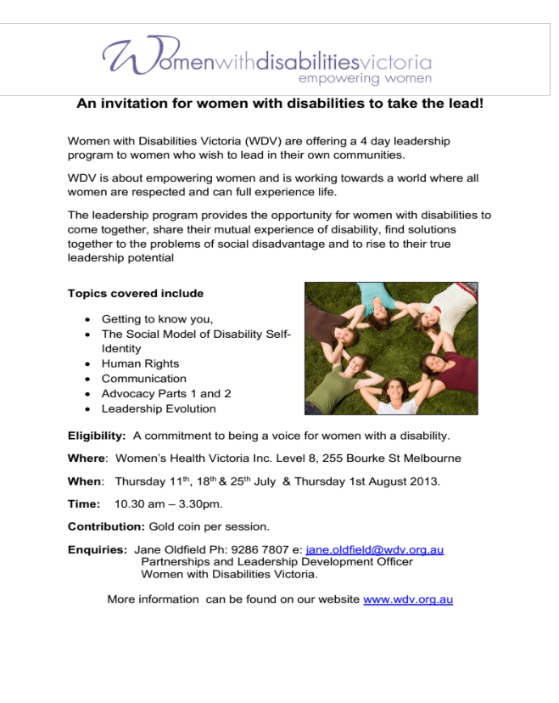
Image description: A WDV flyer promoting the first program in 2013.

“When other people see you as a third-class citizen, the first thing you need is a belief in yourself and the knowledge that you have rights. The next thing you need is a group of friends to fight back with.”
Judy Heumann.

Judy is an American Disability Rights Activist. She is known as the mother of the Disability Rights Movement.
2013

Melbourne CBD

Facilitator: Jane Oldfield
Co-facilitator: Debbie Deshayes
Participants: 12

With the promise of meeting new people and learning about leadership as a woman with disability, in 2013 twelve women from Melbourne’s CBD became the first ever participants of the Enabling Women Leadership Program.

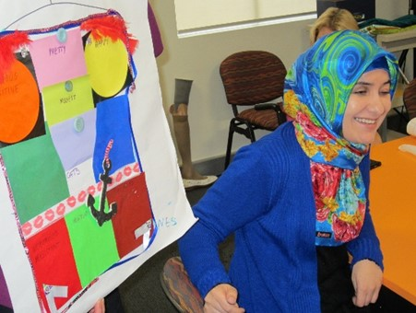
Image description: Participant, Nessa, who was part of the first program.

“What a great opportunity to be amongst a room full of amazing women, inclusive from the onset.”
Enabling Women participant, 2013

Gippsland - Traralgon

Facilitator: Jane Oldfield
Co-facilitator: Nina McDonough-Monahan
Participants: 8

Confidence was key for the participants of the Gippsland program in 2013. The eight women from Traralgon, Bairnsdale and surrounds, were eager to make connections and build on their confidence as leaders and advocates.

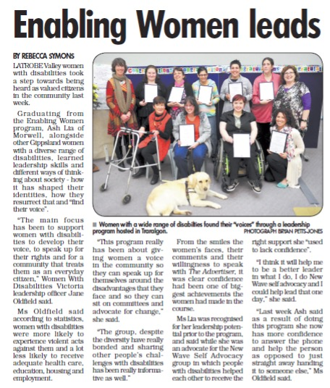
Image description: Enabling Women leads article from the Advertiser newspaper.

“I’ll think more positive about myself. I am a confident person.”
Enabling Women participant, 2013.

2014

South East - Dandenong

Facilitator: Jane Oldfield
Co-facilitator: Janice Slattery
Participants: 10

Enjoying her third time facilitating the Enabling Women Program, Jane Oldfield brought together ten women each at their own stage of disability, but all with a passion for rights and advocacy.

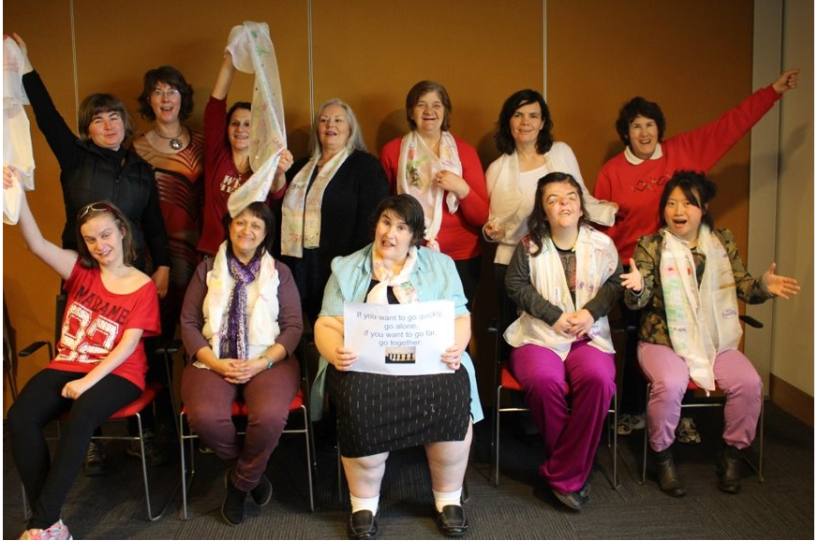
Image description: A group of participants, smiling, holding up their strengths scarves.

“I’d like to say here that when this group came together I was a bit anxious about their ability to come together as a team because they were so diverse in their abilities. But my fears were unfounded. This group has been incredibly supportive and accepting of each other and I think the real growth has come though the really supportive environment.”
Enabling Women Program Facilitator, 2014.

Barwon - Torquay

Facilitator: Jane Oldfield
Co-facilitator: Di Barnes
Participants: 11

The 2014 Torquay Program appears to be the ‘origin story’ for many key events. Whilst WDV stalwarts like Deb Haygarth sprouted the seeds for the first WDV leadership hub; with new found confidence, fellow participant Carolyn Pimentel went on to further develop and win the 2016 Women in Community Life Award.

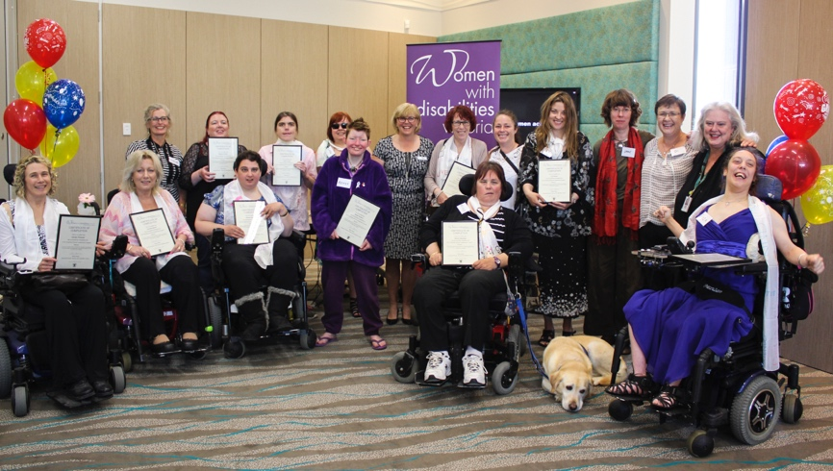
Image description: A group of participants, smiling, holding up their strengths scarves.

“I gained confidence to step up to whatever comes my way.”
Enabling Women participant, 2014.

Gippsland - Sale

Facilitator: Cath McNamara
Co-facilitator: Lynn Lancaster
Participants: 11

In 2014 the Program was back in Gippsland, this time delivering in the regional hub of Sale. Supported by an active Reference Group, positive feedback came from participants and stakeholders alike. Some graduates inspired to seek further opportunities in advocacy.

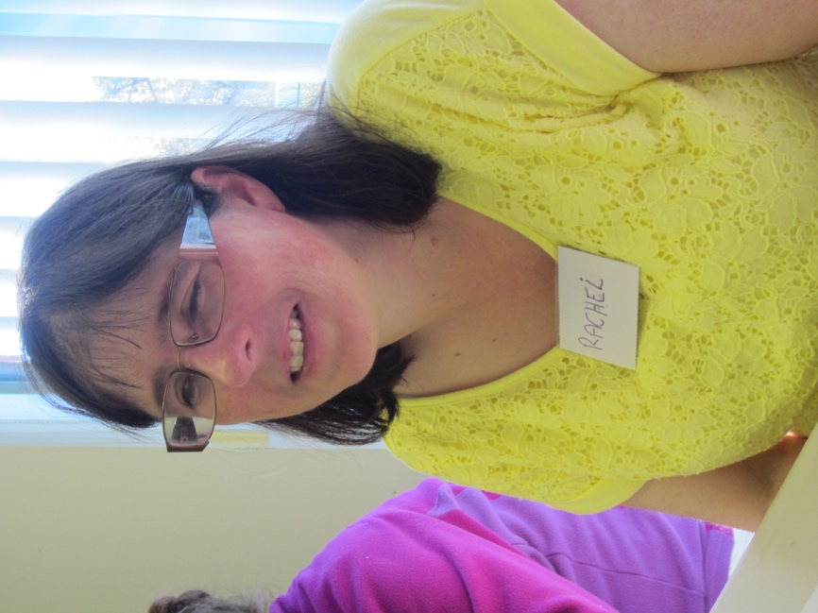
Image description: Participant Rachel, smiling, wearing glasses and a yellow top.

“The Program has had a very positive influence and created positive change.”
Enabling Women participant, 2014.

2015

Warrnambool

Facilitator: Cath McNamara
Co-facilitator: Rose Egerton
Assistant: Bec Biddle
Participants: 9

Heading down to the South West coast, facilitator Cath was met with a creative bunch of participants in Warrnambool. The welcoming and friendly environment was the perfect place for participants to work creatively on their strength scarves and budding friendships.

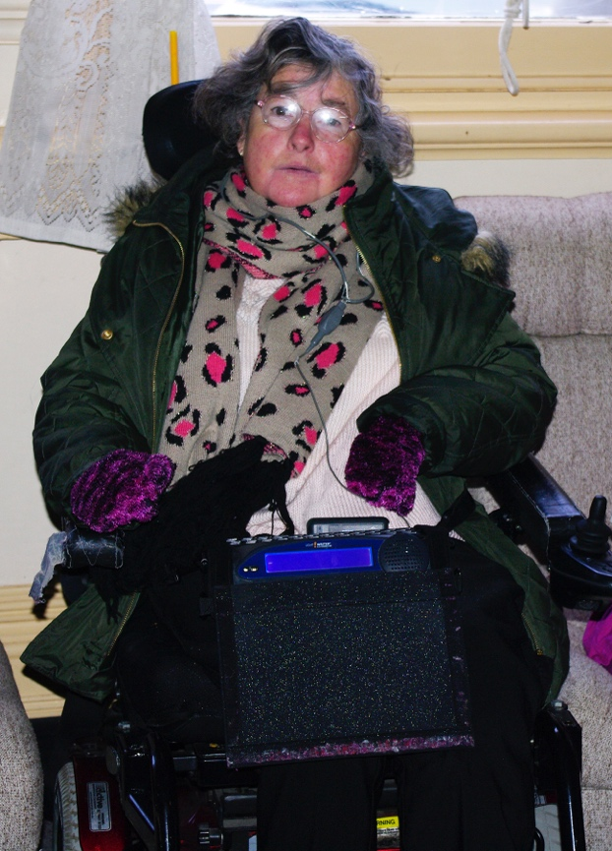
Image description: Participant Dawn, smiling wearing glasses, jacket and animal print scarf.

“I feel stronger to help others while also helping myself.”
Enabling Women participant, 2015.

Goulburn Valley

Facilitator: Jane Oldfield
Co-facilitator: Sharon Sellick
Participants: 13

Showing maturity, courage, and a readiness to support each other, the 2015 Shepparton Program, was all about solidarity and celebrating each other’s goals. For this group, there were and are lots of goals and lots of achievements. Many of the participants have followed on from the Program with projects that contribute to the accessibility and inclusiveness of Goulburn Valley region and beyond.

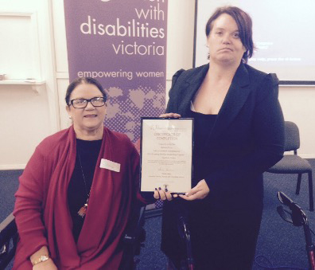

Image description: Belinda holds her graduation certificate. She is next to her mentor Colleen.

“I’ve learnt about the strengths everyone has.”
Enabling Women participant, 2015.

Dandenong - Youth

Facilitator: Beth Atkins
Co-facilitator: Sarah Jane Hayward
Participants: 9

The Enabling Younger Women Program was piloted in early 2015. It focussed on the experiences of young women with disability, aged between 15 and 20 years. The Program aimed to better equip participants in the transition from school or other settings to the next stage of their lives. The Program was piloted with a group of young women from Emerson School who gained confidence in speaking publicly and a clear vision of where they wanted to go with a strong sense of purpose in their graduating year.

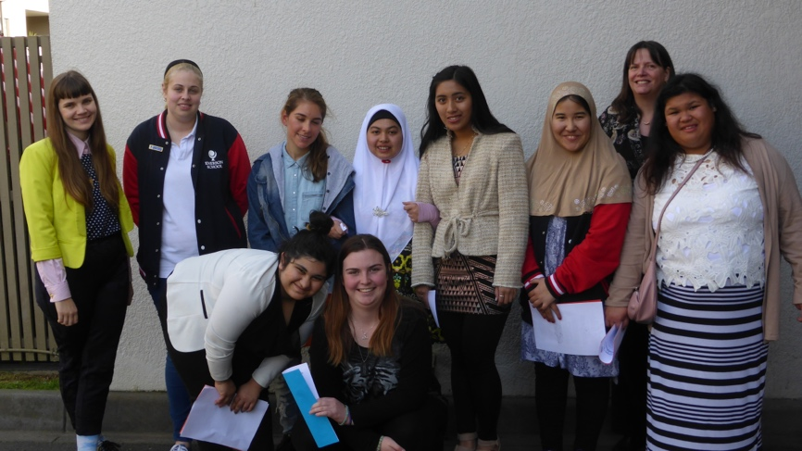
Image Description: Some of the Enabling Younger Women Program group with facilitators Beth Atkins and Sarah Jane Haywood.

“I believe this program has the potential to make a real difference for young women and am pleased to have been involved.”
Enabling Younger Women, Project Consultant.

South Morang

Facilitator: Jane Oldfield
Co-facilitator: Vildana Praljak
Participants: 13

Every group of Enabling Women participants is unique. This Melbourne North East group was no exception. With many members of this Program living with invisible disabilities, the sessions explored how participants manage not just their disability but often people’s unrealistic expectations of them too. Through that adversity, the courage and resilience of this group was clear. Many participants setting their goals on stepping up in their community.

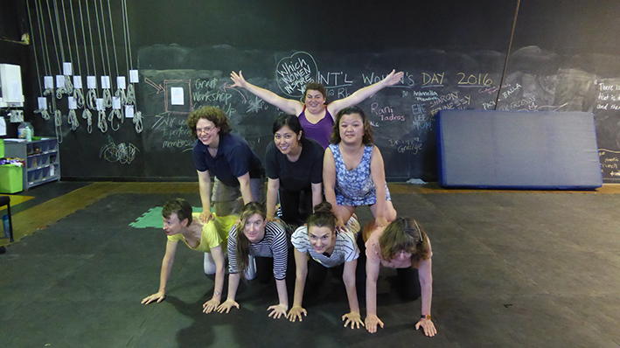
Image description: Participants at their reunion at the Women’s Circus in West Footscray.

“I have grown and I know more strengths more.”
Enabling Women participant, 2015.

2016

Wangaratta – North East Victoria

Facilitator: Jane Oldfield
Co-facilitator: Tracey McGeehan
Mentor Coordinator: Bern Fraser
Participants: 13

Participants from Wangaratta agreed it was both a privilege and a pleasure to be part of an amazing group of women. Women’s Health Goulburn North East (WHGNE) played an integral role for this Program. As the key partner WHGNE provided substantial support in planning and delivery, as well as conducting a comprehensive evaluation.

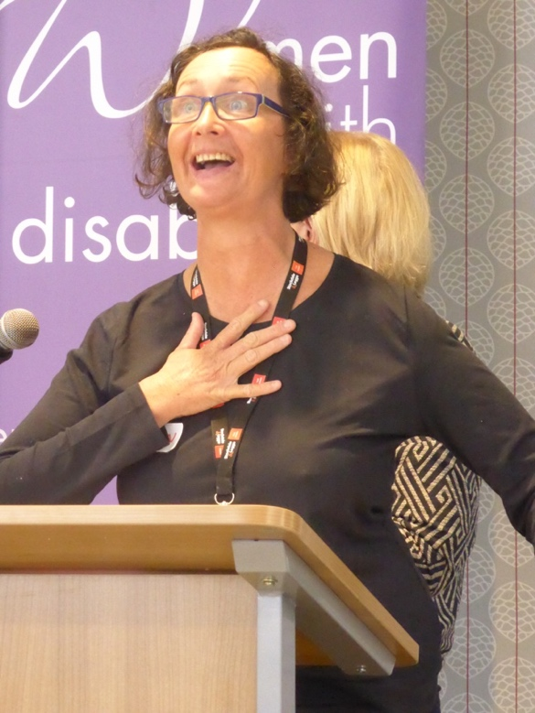
Image description: Megan making a speech at graduation.

“I’ve made new friends here. You’re all in my heart.”
Enabling Women participant, 2016.

Doncaster – Inner East Melbourne

Facilitator: Jane Oldfield
Co-facilitator: Eleanor Shultz
Mentor Coordinator: Lara Wallis
Participants: 12

Kicking off in the Spring of 2016, the Doncaster Enabling Women Program was led by veteran facilitator Jane and co-facilitator Eleanor. Local woman Eleanor impressed the recruitment panel with her commitment and saw her potential as a wonderful role model. The group also clicked in the supportive environment working collaboratively and as individuals.

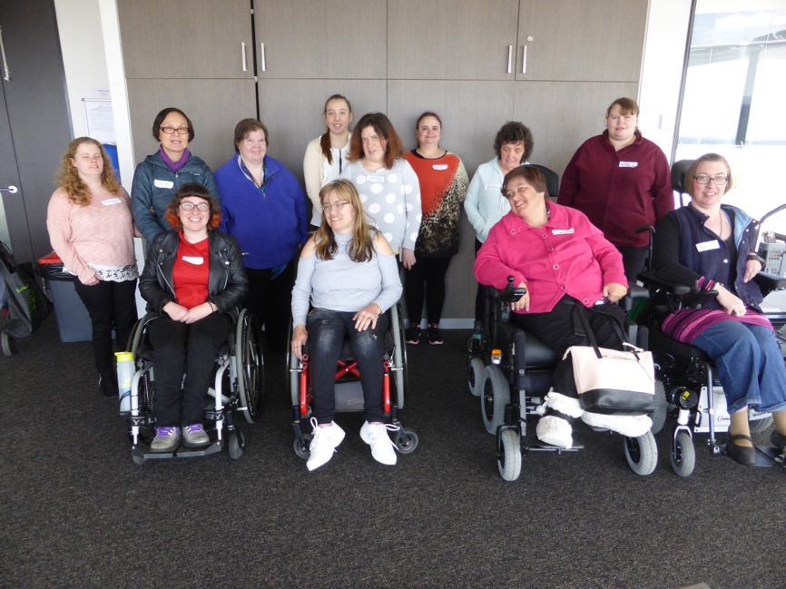
Image description: The Doncaster Program participants all together.

“Yes. I will stand up for women with disabilities when they are being mistreated. I am a proud disabled lady and will tell everyone who will listen.”
Enabling Women participant, 2016.

Footscray – Melbourne West Region

Facilitator: Cath McNamara
Co-facilitator: Soreti Kadir
Participants: 6

Together with Maribyrnong City Council, WDV delivered Enabling Women to participants of Melbourne’s West. A timely delivery on the back of the Bulldogs premiership breaking drought, a celebratory vibe was felt throughout the Program. Future WDV manager Liz Wright would also have her first introduction to the Program with her role at the time in Metro Access.

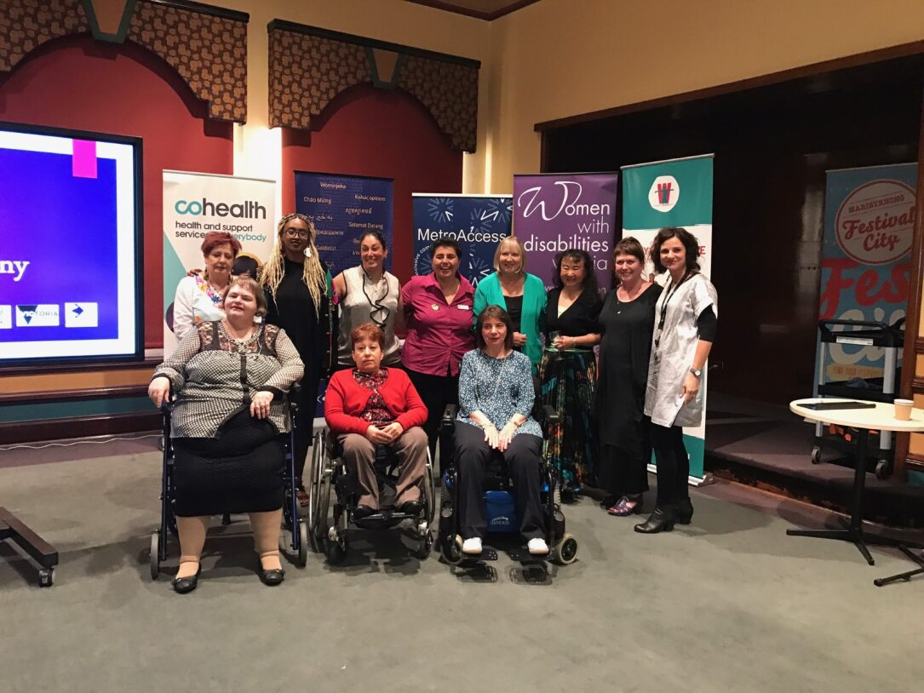
Image description: A group of participants all together for graduation.

“The Program has given me the opportunity to explore avenues for growth, alongside fellow participants, and with the assistance of our caring and capable facilitators.”
Enabling Women participant, 2016.

Bendigo

Facilitator: Cath McNamara
Co-facilitator: Maureen McMahon
Participants: 5

A small but mighty group of women assembled in one of Victoria’s largest regional centres for the 2016 Enabling Women Program. The five day leadership course designed for women who wish to lead in their own communities, provided a space for learning and sharing. Dedicated to changing perceptions and advocating for equity, one participant Ellie Stewart has since gone on to be a great changemaker for the Deaf community.

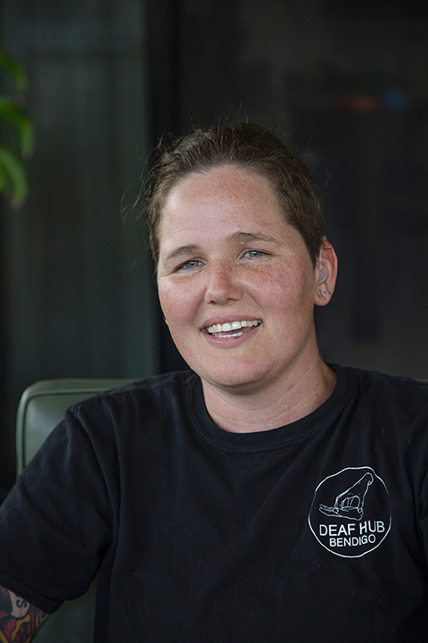
Image description: Elise is smiling, looking straight at the camera.

“The group was small but very enthusiastic. It was great to see how participants supported each other and grew in confidence and pride as disabled women.”
Enabling Women Lead Facilitator, 2016.

From the Outskirts

To celebrate her advocacy, WDV spoke with Elise Stewart as part of the 2023 podcast series From the Outskirts.

The podcast, hosted by Community Inclusion and Women’s Empowerment Team Manager Liz Wright, introduces listeners to musicians, mothers, partners, artists and changemakers.

All so different, yet united by their experiences of the world around them as women with disabilities.

Available for download and streaming in a variety of formats the series has been championed across the State and beyond.

wdv.org.au/episode-9-elise-stewart/


Identity bags

Our Identity Bags helped us explore who we are, including the things that we can and cannot change.

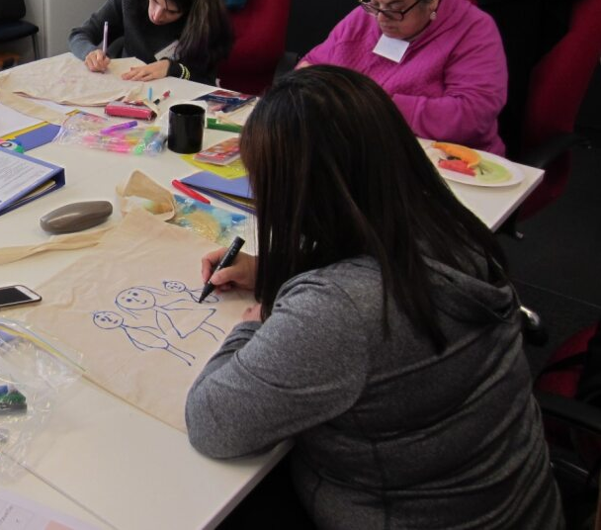

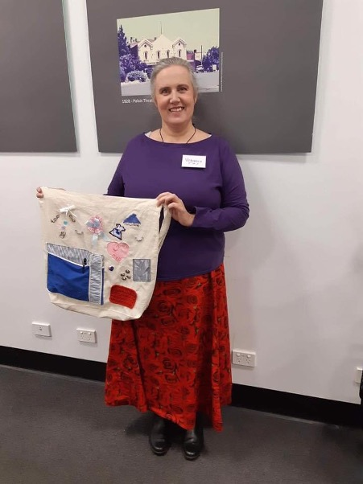

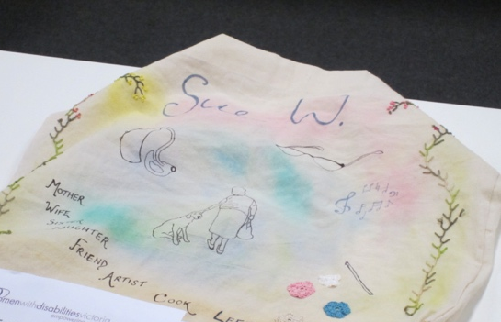

Image description: A collection of Identity Bags created by Enabling Women participants.
The Mentor Program

From volunteers in the community, women and non-binary people with or without disability, are matched as mentors with Enabling Women participants. Mentors work with and support participants in their pursuit of achieving a leadership goal.

Completing the 2014 Torquay Program, Deb Haygarth was the first participant to have a formal mentor.

“I gained confidence to step up to whatever comes my way,” she said at the time.
With that success WDV then trialled a more formal mentor program the following year.

The Shepparton Program was the first Enabling Women to incorporate the Mentor Program, where many members of the Reference Group eagerly put their hands up to be mentors.

Since then mentorships have become a celebrated staple of the Program. Partnerships have seen great things happen and lasted years.

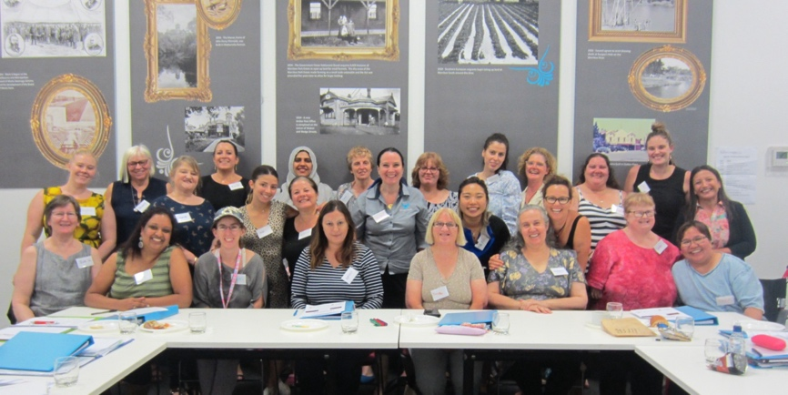
Image description: Mentors and participants from Wyndham Program in 2019.

Kylie and Kate

“I am so pleased to have been involved in the 2018 Enabling Women Program in Frankston where I mentored Kate. Kate and I were a perfect match from the start!

I am a female who has lived experience of being hearing impaired, work in public health and in my spare time participate in paper craft (mainly card making).

Kate is also a craft lover and was taking painting lessons when we first met. We knew early on our goal would be craft related- we decided I would teach Kate card making.

I regularly attended Kate’s home and shared my love of paper and card making skills with Kate.

Due to her disability, we would write simple instructions and film each step so Kate would be able to complete this without me around.

It fills my heart with joy to see Kate in her element creating beautiful cards for people who she loves the most.
Kate fondly calls her craft room ‘Craft HQ’ and frequently indulges in a what she refers to as ‘creative medicine’.

Kate’s eye for colour and unique design makes her card designs stand out from others. I will be forever grateful for my experience in the Enabling Women Program which introduced me to Kate who I am sure will be a friend for life.”

Mentor, Kylie Webb,
2018 Frankston Program.

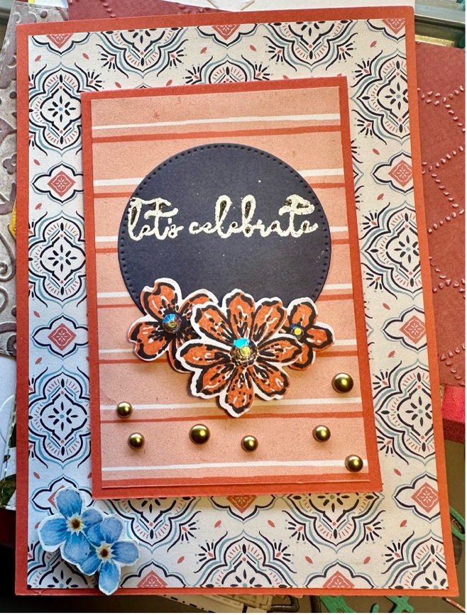

Image description: A beautiful handmade card with the words: “Let’s celebrate.”

Participant and mentor quotes

"At this midway point I feel confident in saying that all participants and all mentors have found the experience extremely worthwhile."
Mentor Coordinator.

“Overwhelmingly they were very positive when speaking of the role their mentors have played in their progress thus far. With one participant noting in the mid-way evaluation of the Leadership Program that her greatest success so far had been meeting and learning from her mentor, and another saying, I hope this Program continues. I would like more training, advocacy, and mentoring."
Mentor Coordinator.

"I learnt from my mentor to always empower myself and never feel intimidated."
Enabling Women participant.

"I learnt about the experience of living with a different disability and some of the commonalities. [She] also provided different options, solutions and perspectives."
Enabling Women participant.

"My mentor made a whole lot of difference, my aim was not possible without her input."
Enabling Women participant.

"I was really happy to have the mentoring as part of the course, and this really added to the benefits of it."
Mentor.

Empowering Leaders

Just over a month ago, a group of wonderful ladies met.
All strangers to one another, no one knew what to expect.

The discussions started to happen, and the women all opened up.
And started to chat to one another, while filling up their cups.

Meals were shared and laughter rang, while leaders we became.
Overcoming extensive barriers, we stood proud of our names.

And as our program draws to a close, we feel sadness kicking in.
Graduation will be the last, but for us we just begin.

To head out in the community, strong advocates we will be.
Thank you, Bridget, Amber, Liz, Jenny and all our interpreters and mentors, who helped us to see.

A poem by Enabling Women participant, Leonie.

2017

Cobram – Moira Shire and beyond

Facilitator: Jane Oldfield
Co-facilitator: Renee McCarthy
Mentor Coordinator: Jenny Godwin
Participants: 12

Inclusion and group discussion was central to the 2017 Moira Shire Program. Learning about the rights of women and rights of people with disabilities was vital for participants. They explored what and how these worked in different dynamics together.

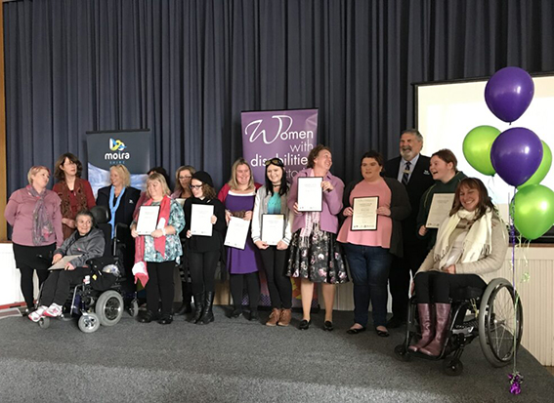

Image description: A group of participants on stage holding their graduation certificates.

“When we talked about human rights, I loved learning about it.”
Enabling Women participant, 2017.

Inner West Melbourne - CALD

Facilitator: Jess De Mercurio
Co-facilitator: Agnes McDermott
Participants: 8

In 2017 WDV partnered with Maribyrnong City Council, Multicultural Centre for Women’s Health and Women’s Health West to deliver the Enabling Culturally & Linguistically Diverse Women Leadership Program (ECW). Revised to support the experiences of women at the intersections of gender, disability and ethnicity, the ECW Program enabled participants to explore leadership from different perspectives in a lively and supportive space.

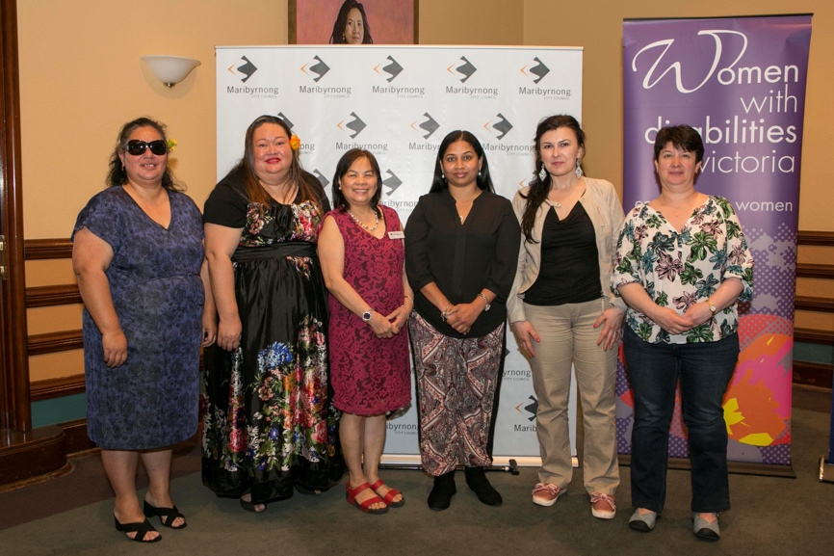
Image description: Program participants with the Mayor of the City of Maribyrnong, at the ECW Graduation celebration.

“We are all different and we learn about ourselves when we learn about others.”
Enabling Women participant, 2017.

Northcote - Inner North Melbourne Metropolitan Region

Facilitator: Carly Myers
Co-facilitator: Chloe Millar
Mentor Coordinator: Mary Henley-Collopy
Participants: 9

Confidence and connections were key themes for the Melbourne Inner North Program. It was also the first time now WDV CEO Nadia Mattiazzo learned about the Enabling Women Program.

Working at the City of Yarra, Nadia sat on the Reference group and was a mentor. Like many supporters from partner organisations, Nadia observed how Enabling Women supported the empowerment of women with disabilities and in ways that had not been tried previously.

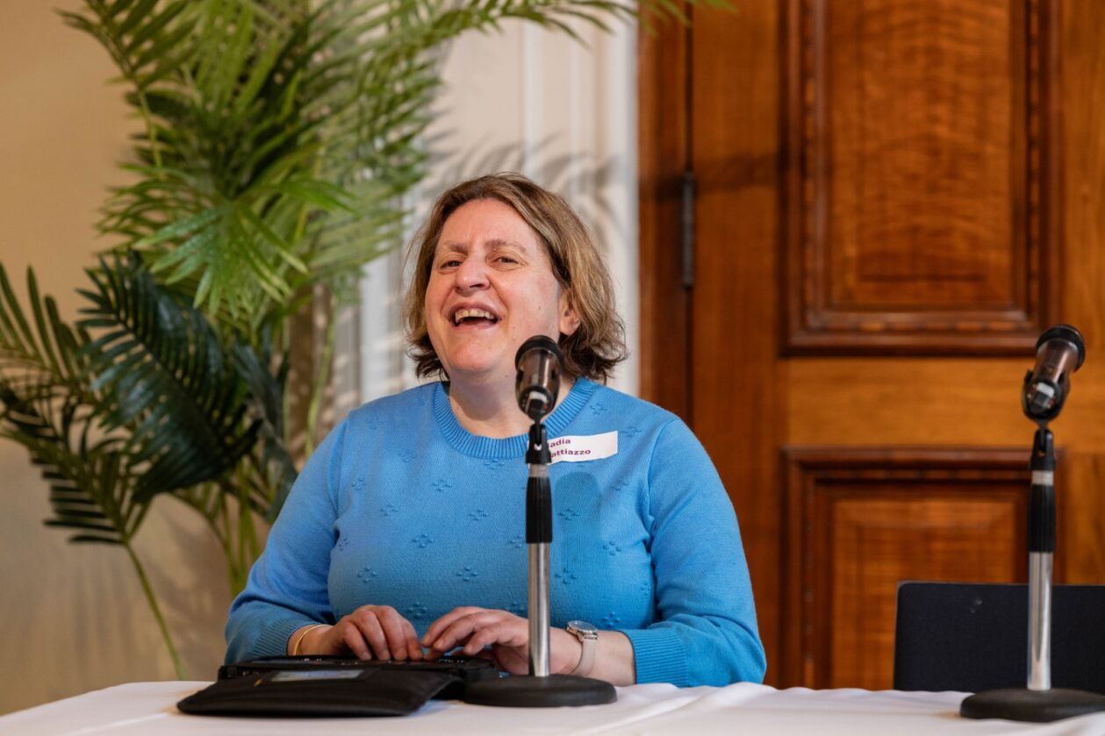
Image description: Nadia Mattiazzo uses a Braille note-taking device, whilst speaking into a microphone.

“I had not really been aware of anything that looked at leadership from these types of perspectives… And knowing it was so important for people, including those who were new to disability, or experiencing isolation.”
Nadia Mattiazzo, CEO of WDV.
Ballarat – Central Highlands

Facilitator: Carly Myers
Co-facilitator: Erin Ure
Mentor Coordinator: Concetta McFall
Participants: 9

Filled with keen and talented artists, the Ballarat participants found a comfortable space with Enabling Women’s craft activities and developing friendships. As they grew in confidence, the participants continued to support each other. Ultimately flexing their newfound skills by advocating for themselves and other women with disability in their community.

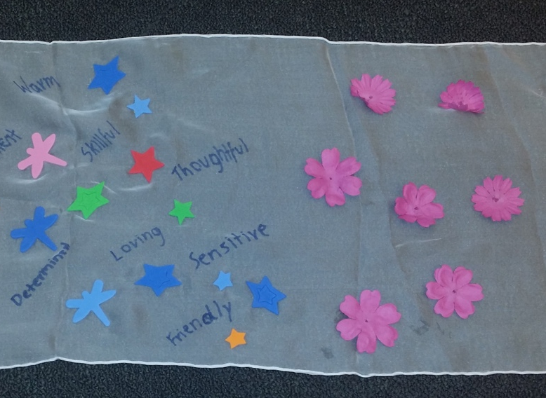
Image description: A strength scarf decorated with felt flowers, dragonflies, stars and words.

“I can now go out there and decide my life and make my own decisions and not let fate control it.”
Enabling Women participant, 2017.

Wodonga and surrounds

Facilitator: Jane Oldfield
Co-facilitator: Vickie Prescina
Participants: 9

Entering new spaces filled with questions and unknowns can be daunting. The participants of Wodonga 2017, however, overcame anxieties and apprehensions to come together in the most powerful ways. Supporting each other with simple acts of kindness like asking each other’s opinion was a testament to their solidarity as a group.

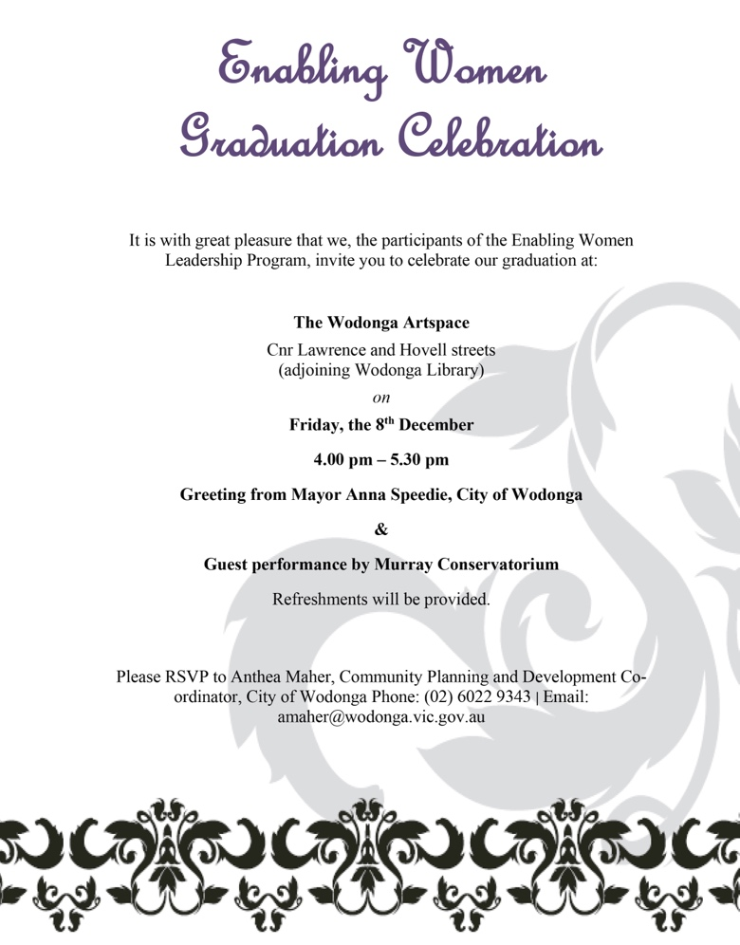
Image Description: A copy of the Graduation invitation for the Wodonga & Surrounds Program.

“...that I am a good person.”
Enabling Women participant, 2017.

Gippsland – Leongatha – Youth

Facilitator: Jess Mecurrio
Co-facilitator: Bethany Minister
Participants: 8

After a successful pilot Program in 2015, Enabling Young Women (EYW) was delivered in Leongatha, Gippsland. Refined through the learnings from the pilot, EYW Program met the needs of participants at the intersections of youth, disability and gender, with new resources and areas of topics explored to better meet the Program’s emerging leaders.

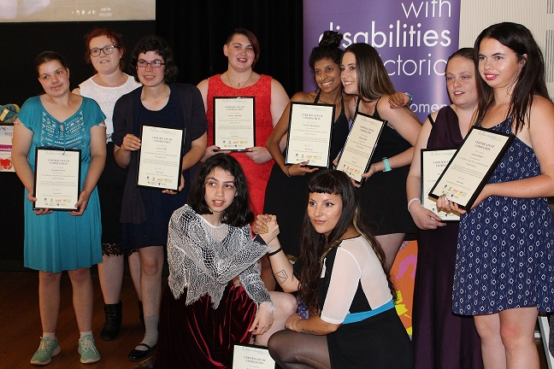
Image description: Program Participants hold Graduation certificates and the facilitators clasp arms in solidarity.

“I learnt how to treat others.”
Enabling Women participant, 2017.

Self care

Self care is when you do things to look after yourself. The Program covers the importance of allowing ourselves to be pampered, and to rest. These are ways to respect and show care to ourselves. Self care also reminds us that we are worth it.

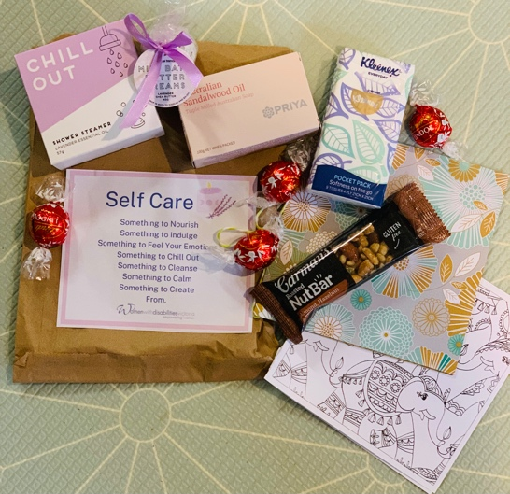

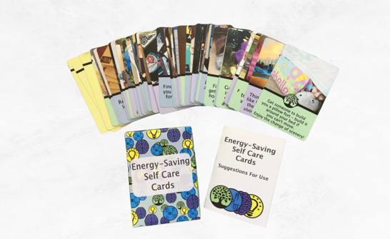

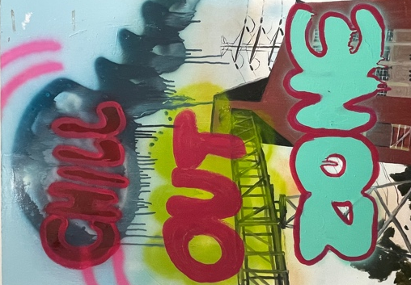
Image descriptions: Self care packs sent to participants. Energy-saving self care cards. Artwork that says: Chill Out Zone.
Strength scarves

Our strength scarves recognise and celebrate our strengths both fully grown and emerging.

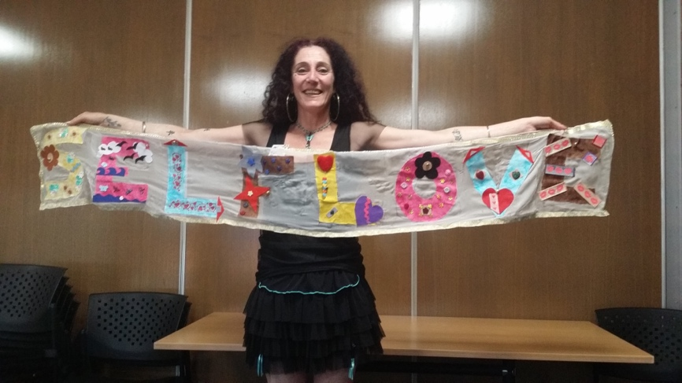

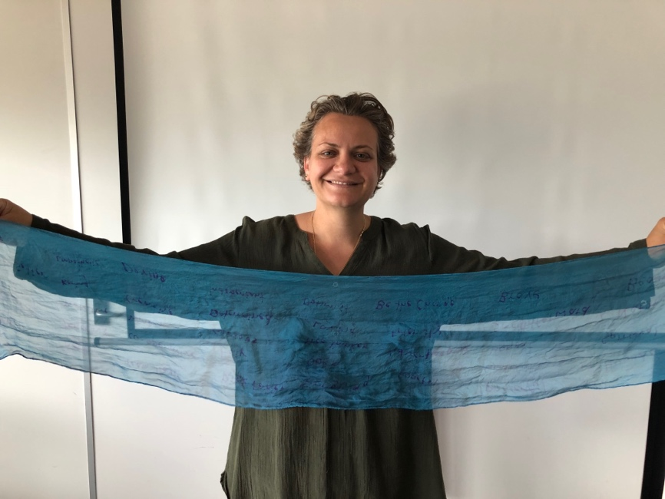

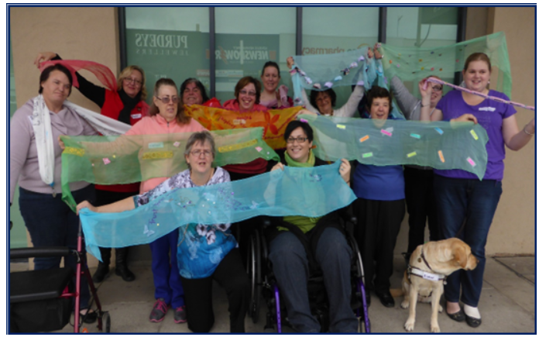

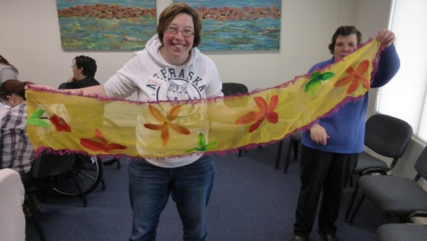

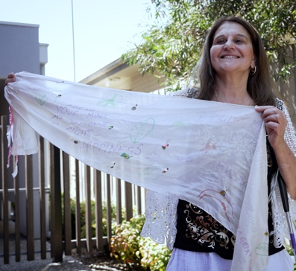

Image description: Five different pictures of individuals and groups of women holding and wearing their strength scarves.

Graduation speech from participant Helen

“During the second session of our program we were encouraged to create what has been termed a ‘strength scarf’.

Our brief? That the scarves are to represent us developing new skills; such as becoming more confident and empowered. During the following three sessions, we had some time to build and create this representation of strength. Our blank canvas, being a length of plain, scarf fabric. Our tools; being our imagination and a variety of provided craft items.

As you can see, what has developed, is unique to each one of us and our journeys.

Running alongside this thread of thought, was also an activity, where we recorded our co-participants’ strengths, adding to the list, each time a new strength was revealed. During the final session we shared, via one-on-one discussions, the strengths we had noted.

We also spoke about the pertinence of the words and symbols on our scarves. These sharing activities were thought-provoking and uplifting.

Having the knowledge, that I had been nominated to speak about the scarves, I took particular note of, and was fascinated by, each story as it unravelled. To me, it is evident that our personalities and interests are strongly represented on our scarves. Each collage depicts areas of our lives that we are passionate about and reflect our individual strengths.

I see persistence, creativity, thoughtfulness, calmness, enthusiasm, dedication and positivity reflected in these creations.

I encourage you, after the formal part of the evening has concluded, to ask myself and fellow participants, about the significance and thought processes behind our creative works.

Thank you for your attention and please do enjoy the rest of the evening.”

Co-facilitators

Renee McCarthy

Few people embody the Enabling Women journey quite like Renee McCarthy. Doing the Program as a participant in Shepparton in 2015, Renee then began the 2016 Wangaratta Program as Reference Group member before becoming a Mentor. In 2017 she would enjoy the opportunity to become the Cobram Program’s Co-facilitator.

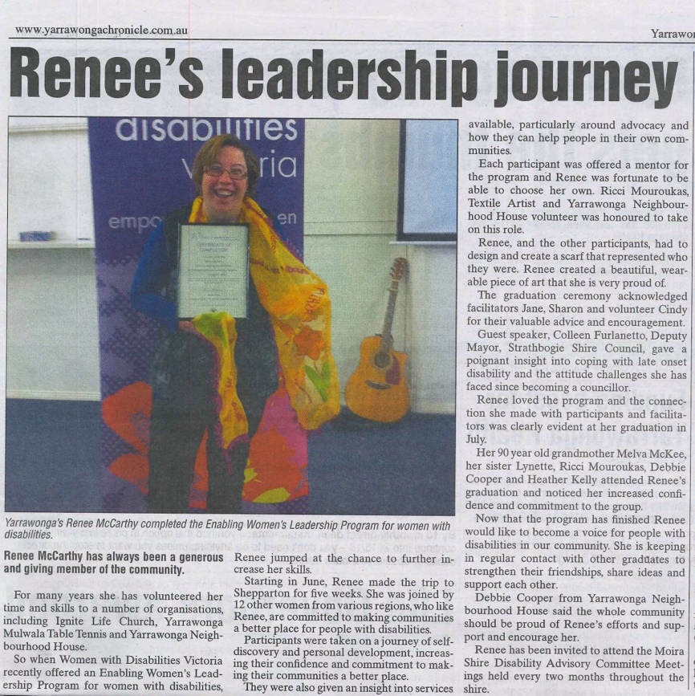
Image description: A newspaper article about Renee’s leadership journey.

Claire Farrell

“I will like say congratulations to all of the women that have done all a good job in the program and also so proud of you all.

You have all done an excellent job. I hope you are all so proud of yourselves, you have learned a lot from this program with WDV.

So, I hope you are proud of what you have done well in this and also have you walk away from this and following with what we all talked about and were going to catch up and keep in connected with each other and also, we are all so proud of you all.

So, thank you to all the staff from WDV. I am so proud of you all. I love what I have done and I am happy with everything we have done.

I have enjoyed myself doing the program. Also to all WDV staff that also have been in the program and also spoke about what you all do in your roles and we have learned a lot what you have told us.”

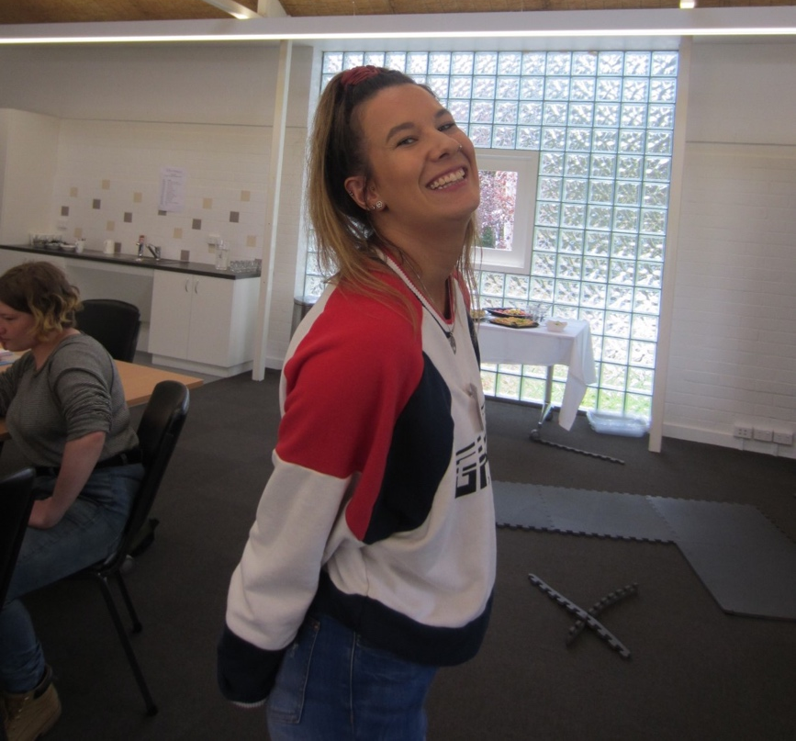
Image description: Program Co-facilitator, Tahnee Daniel.
Vanessa Davis

“Participating in the Enabling Women Program has been one of the most heart-warming and fulfilling experiences, not only in terms of work, but in life as a whole. The Program empowers participants to become more confident and learn a great deal about themselves in the process. By sharing our experiences and life lessons, it helped me break out of a shell I didn’t even know I had. This community has allowed me to embrace who I am, recognising that everyone is different and that it is not up to us to change who we are or make ourselves uncomfortable in order to fit into society.”

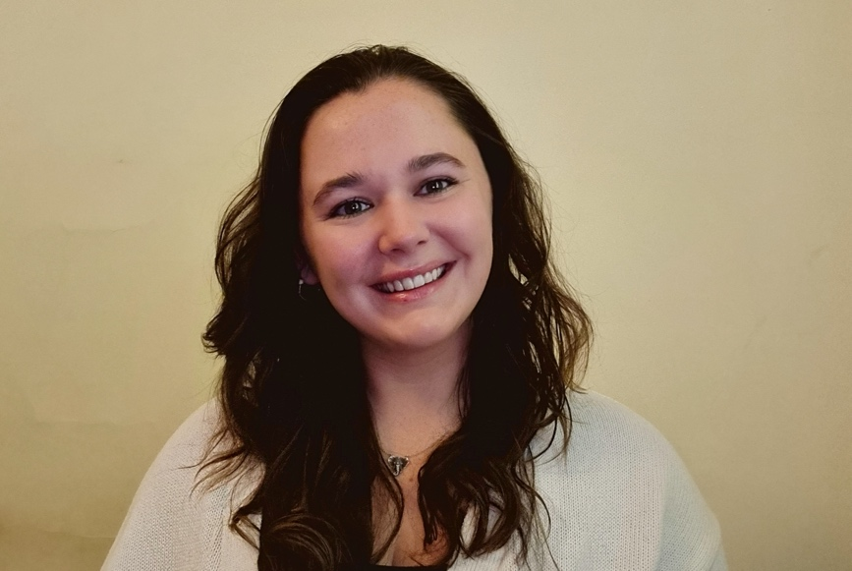
Image description: Vanessa Davis, Enabling Young Women Co-facilitator. She smiles warmly to camera.
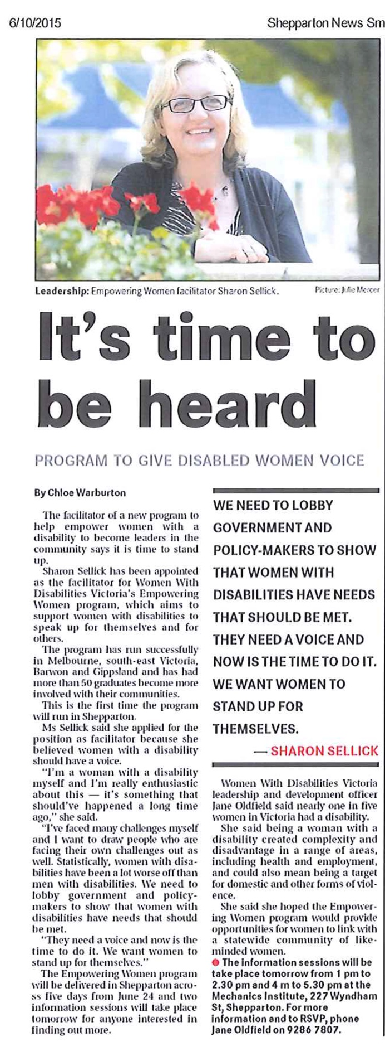

Image description: Shepparton News article about Co-facilitator, Sharon Sellick.

Outer East Region

Facilitator: Jane Oldfield
Co-facilitator: Keltie Blake
Mentor Coordinator: Lara Wallis
Participants: 12

Inspired by their time together during the Program, participants from Knox expressed a strong desire to keep meeting as a group. Their mission to bring change for other women with disabilities. Led by members of the Program they proposed meeting structures and taking key roles within the group. Extending their expertise throughout the community other participants went on to join Monash, Maroondah and Yarra Council Disability Advocacy Committees.

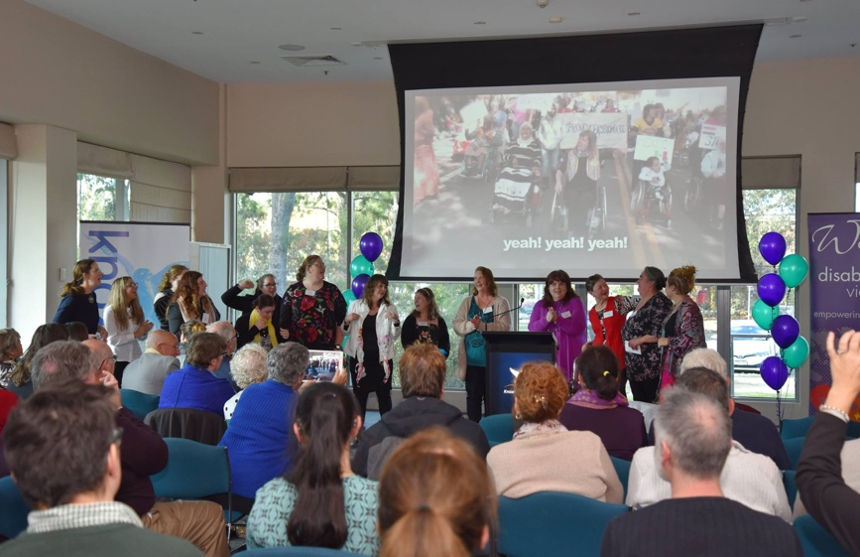

Image description: A group of participants on stage in front of a screen projecting a film. An audience watches on.

“I am genuinely excited about the opportunities ahead of me. I feel like I can do anything again.”
Enabling Women participant, 2018.

Brimbank

Facilitator: Bridget Jolley
Co-facilitator: Jo Thornburn
Participants: 11

The sounds of laughter and feelings of joy were palpable in the 2018 Brimbank Enabling Women. Sharing stories and smiles while working on their strength scarves was balanced by the bravery and comfort in connecting while discussing more serious subjects. Together they bonded, grew and found their place as empowered leaders. People were rocking out at the graduation celebration to a live performance by the Hackkets, with EW participant Victoria lead vocalist for the band.

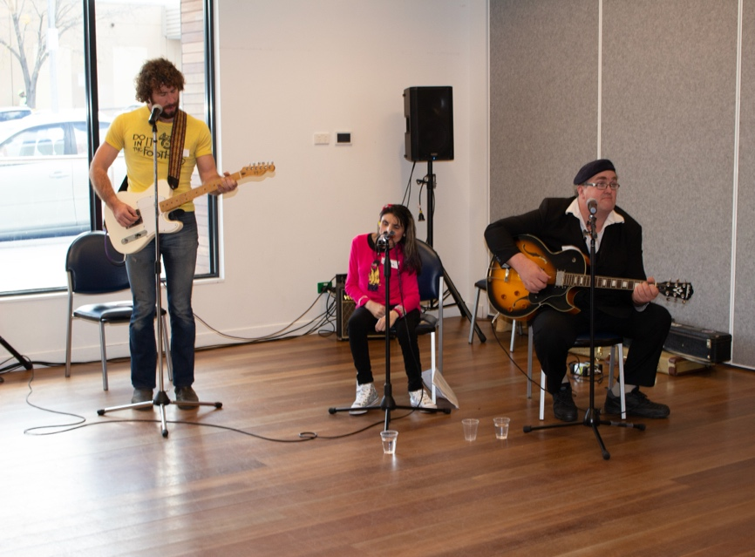
Image description: The Hackkets playing as part of the graduation.

“Very professionally delivered. Well done Bridget on your first facilitation of Enabling Women.”
Reference Group Member, 2018.

Frankston and surrounds

Facilitator: Jane Oldfield
Co-facilitator: Marie Allen
Mentor Coordinator: Maribel Steel
Participants: 13

Late October, participants of the 2018 Frankston program came together with facilitators Jane and Marie. Supported by Mentor Coordinator Maribel, eager Program participants and mentors from the community were matched. Demonstrating the strength of the Mentor Program, many of these matches turned to friendships that endure to this day.

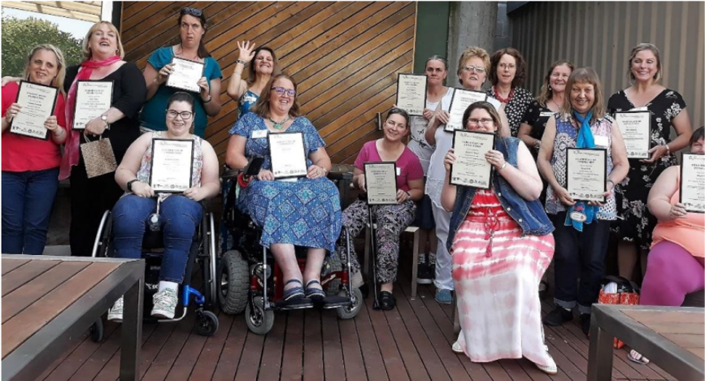
Image description: Participants together holding up their graduation certificates.

“The way forward for me wasn’t quite clear until I embraced Women with Disabilities Victoria, empowering women...the future now looks bright for me.”
Enabling Women participant, 2018.

South East Melbourne - CALD

Facilitator: Sharon Granek
Co-facilitator: Simran Kaur
Participants: 8

Bringing together women with disabilities from culturally and linguistically diverse backgrounds, the 2018 South East CALD Program brought together people with a wide variety of experiences. Despite their differences, participants bonded over shared understandings. Together they explored subjects like the Social Model of Disability and Human Rights.

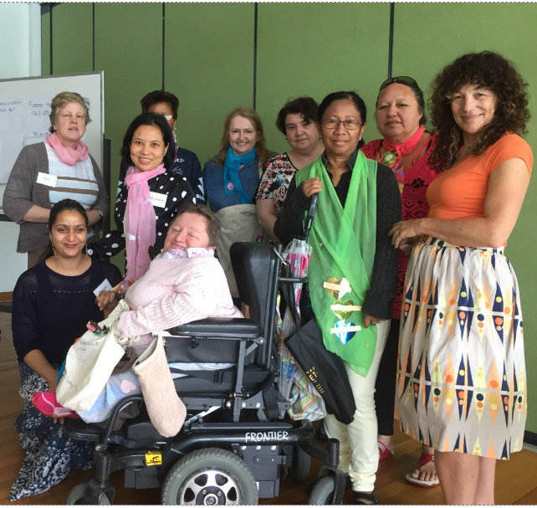
Image description: Participants wear their colourful strength scarves.

“We all have strengths. We are all individuals.”
Enabling Women participant, 2018.

Outer East Region - Youth

Facilitator: Bridget Jolley
Co-facilitator: Tahnee Daniel
Participants: 7

Over six weeks, participants of the Enabling Young Women Leadership Program explored many different subjects to support them on their way to being stronger leaders. They had a lot of conversations about rights, barriers, and advocacy. As well as how believing in their strengths, and newly gained knowledge, they can be better leaders.

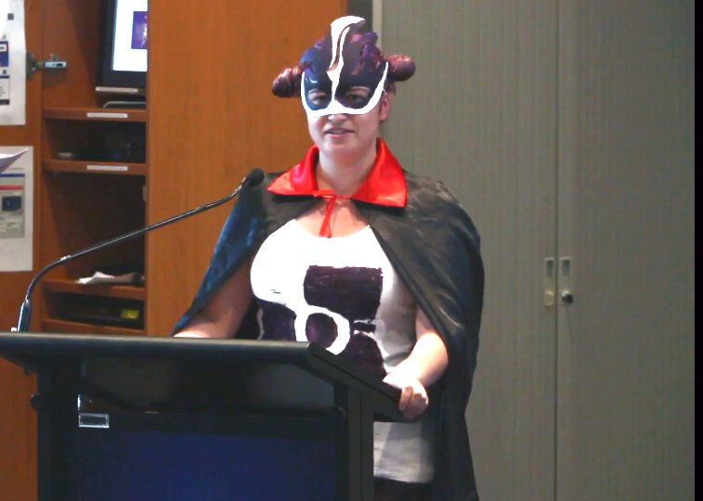
Image description: Roxy at graduation, dressed as superhero for women, CEDAW.

“I feel like the Program kick started my life again!”
Enabling Women participant, 2018.

Barriers

Throughout the Enabling Young Women Program, participants explored some of the common barriers they experience as individuals, and as a group, when wanting to be leaders.

Sometimes, when faced by so many barriers, it can feel like you’re up against a brick wall. Facing this brick wall, it can feel like they will never get to where they want to be. But, throughout the course of the Program, participants looked at ways of breaking these down.

By overcoming these barriers, participants may eventually become the emerging leaders that they want to be.

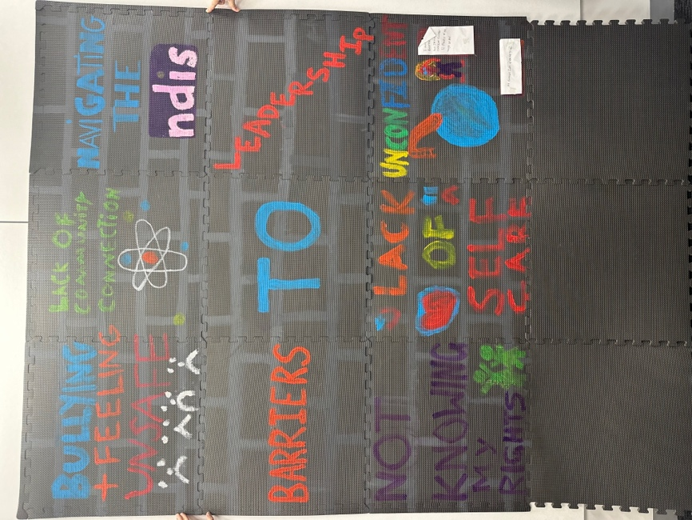

Image description: Different kinds of barriers participants experience, written in bright colours.

Friends and supporters

The Program has had many supporters along the way. Enabling Women is built on the generosity of these allies who know the value of empowered women and non-binary people with disability in their communities.

Former Enabling Women Facilitator and WDV staff member, Carly Myers, has continued her celebrated career in advocacy and speaking up for the rights of women with disability.

Early in 2024 Carly was honoured for advocacy, receiving the Medal of the Order of Australia (OAM) for service to community health, and to people with disability.

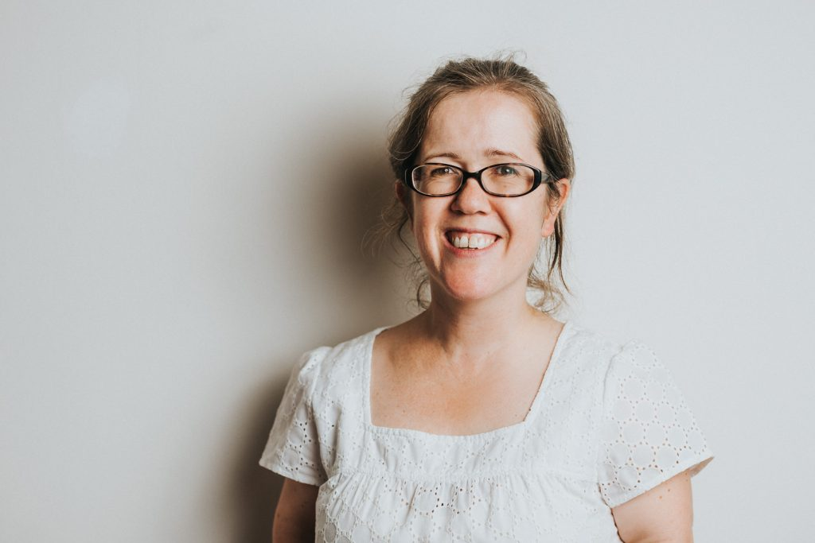

Image description: Carly Myers smiling. She wears glasses and a white top.

“I am honoured and delighted to be here today to celebrate your Graduation from the Enabling Women Leadership Program.
The Mayor of Colac Otway Shire.

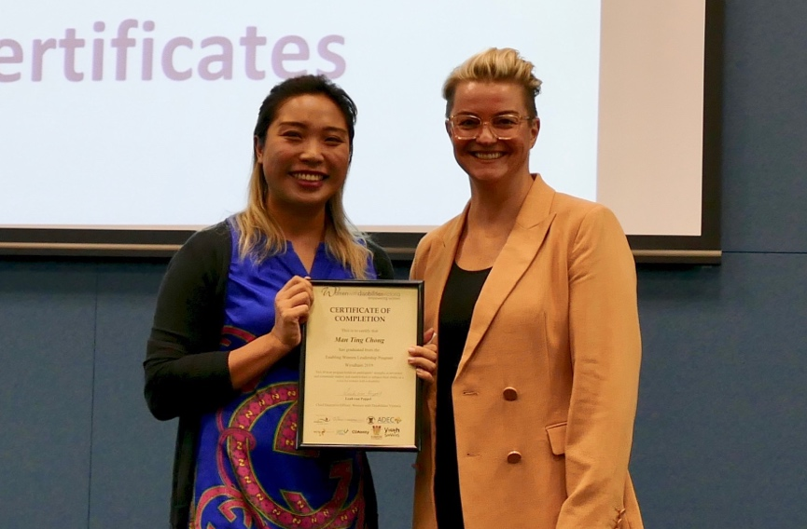

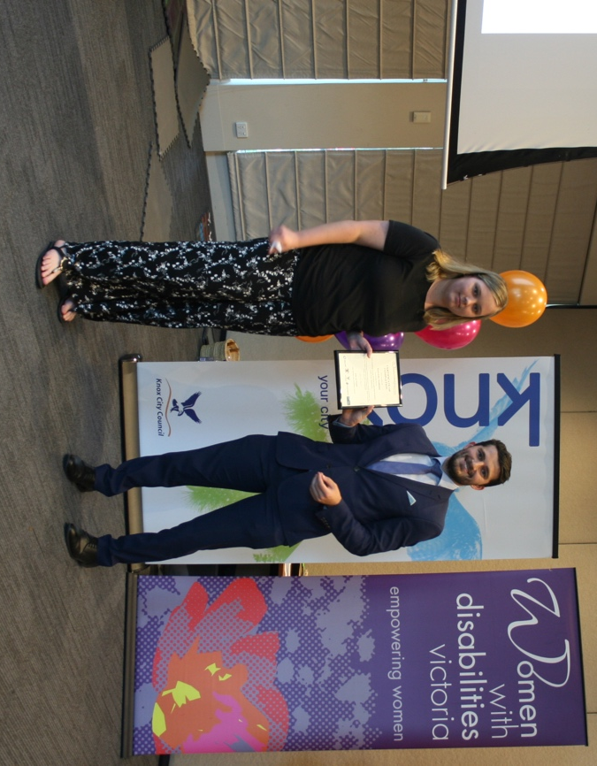

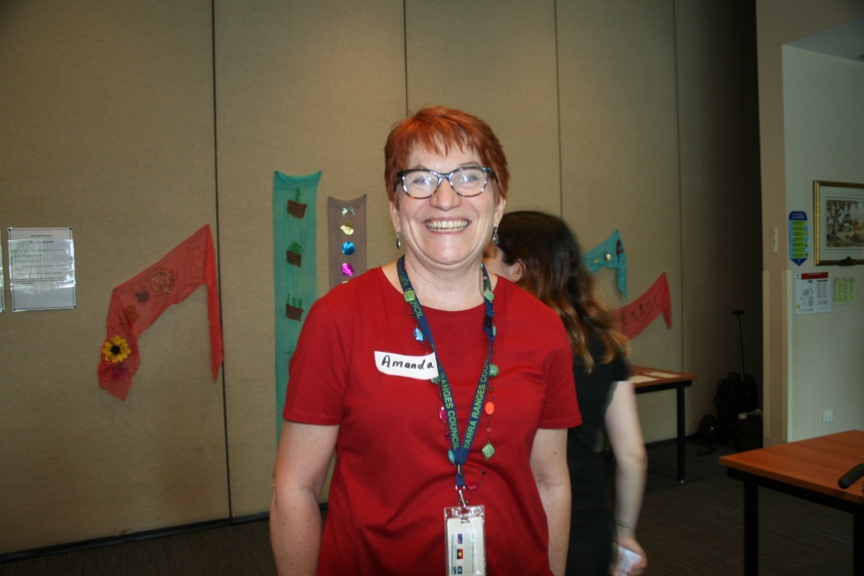

Image description: Three images of Program supporters.

Wyndham

Facilitator: Bridget Jolley
Co-facilitator: Amber Pascoe
Mentor Coordinator: Helen Guest
Participants: 14

Inclusion. This was the mission and the subsequent statement of the Outer West participants. Ensuring an inclusive space from the outset was Facilitator Bridget and Amber, with Reference Group member turned Mentor Coordinator, Helen. With a program high of 14 participants, diversity was wonderfully abundant, inspiring robust conversations and lasting impacts.

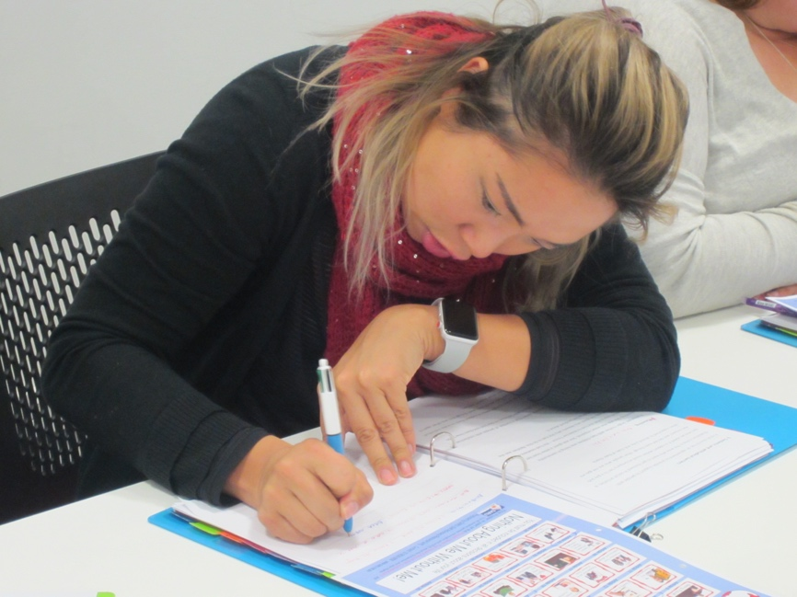

Image description: A participant, writing, fills out her program workbook.

“The first time I heard the word empowering it pushed me to say ‘YES’ right away… There’s something in that word that kicked my frustrated heart.”
Enabling Women participant, 2019.

Bendigo

Facilitator: Bridget Jolley
Co-facilitator: Steph Sayer
Mentor Coordinator: Juanita Miller
Participants: 11

There is strength in connection, a beautiful collaborative feeling that emboldens those involved. The 2019 Bendigo Program is a wonderful example of the power that can happen when women with disabilities come together. By joining in conversations, role playing, and learning about their strengths and identity, this group continues to rally and advocate for all women with disability in the region as the Bendigo Hub.

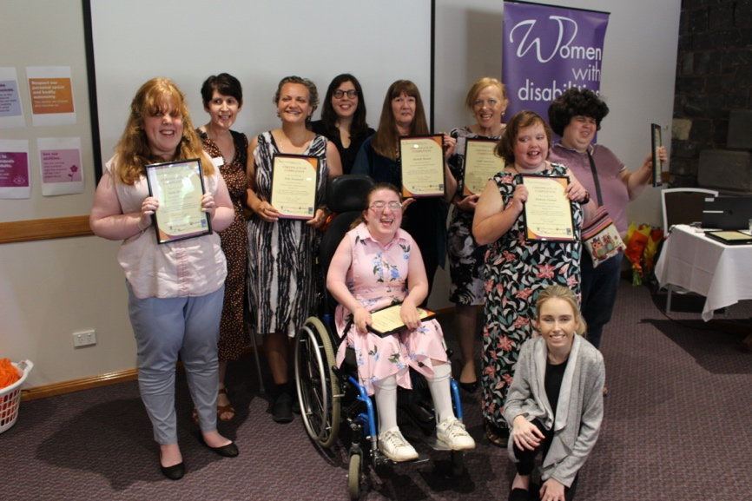

Image description: A group of participants holding their graduation certificates.

“The event has been quite inspiring. The Program has stirred within me a greater desire to speak out, to represent myself and others and to fight against abuses of our basic human rights, including violence and neglect. ”
Enabling Women participant, 2019.

Colac

Facilitator: Brigitte Stone
Co-facilitator: Claire Farrell
Mentor Coordinator: Sarah Fergus
Participants: 7

The first program delivered online in the history of Enabling Women. Experiencing delays through the pandemic and varied impacting factors the Colac participants and local staff were irrepressible in their enthusiasm for the Program. The resilience of this group across the eight-week delivery was celebrated with a fittingly joyful online graduation attended by supporters, stakeholders and family members from across the country.

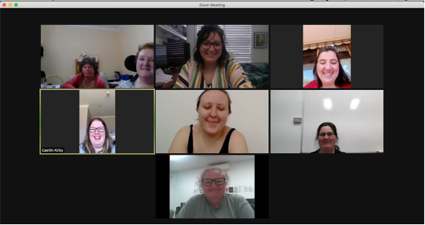
Image description: The 2021 participants taking part in the program via Zoom.

"I am proud of myself because of being in this program and it has been great and it has brought me out of my shell. I don’t feel so scared anymore. I know that I can talk about what I want and also have people to understand and listen to me.
I know there is help out there if I need it. So, I will like to say again, thank you WDV for letting me be involved with this program.”
Enabling Women participant.
Online

With the onset of the Covid-19 Pandemic, the way the world operated shifted to a remote way of doing things. A new buzz word echoed around the vacant city streets, Zoom.

Ahead of the curb though was WDV, who with a state-wide presence had been using the online platform for years prior to the lockdowns.

As the initial panic and uncertainty began to settle and people began to reengage in their communities, the Enabling Women Program sought to bring much needed connection to women with disability, especially in regional areas.
Mandates and restrictions continued to flux, however, after a year hiatus in 2020, WDV committed to delivering the Program no matter the method in 2021.

With another pandemic buzzword, the Program pivoted from an optimistic in-person delivery to accepting a safer online delivery that would go on to be a core element of hybrid delivery moving forward.

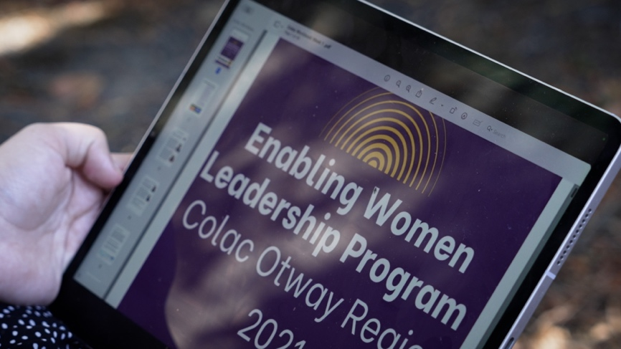
Image description: A participant reading the program guide online on an iPad.

“It was fun, interesting. Still able to attend when sick. Learning and learning from the videos. Opened my eyes up a lot. For yourself and for other families. “
Enabling Women participant.
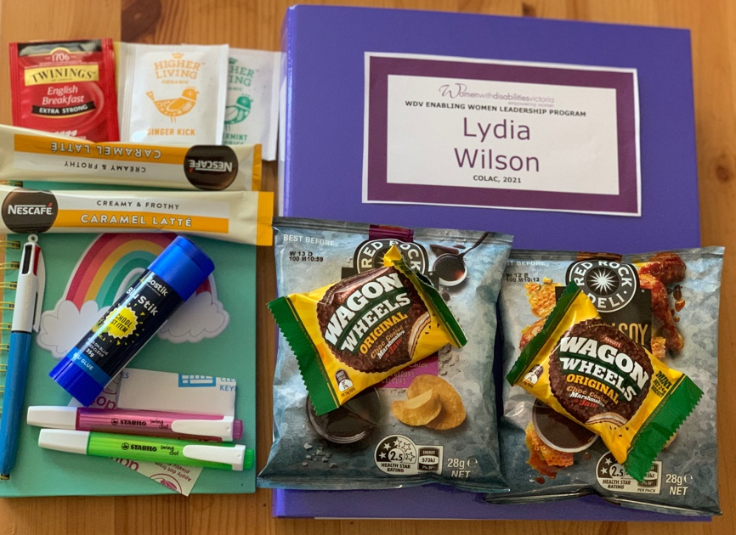
Image description: Packs sent to participants including treats, workbooks and craft supplies.

“Yeah, I find it’s been a little bit easier. Because we are able to chat a bit easier and talk. I am shyer in person.”
Enabling Women participant.

Online graduation celebrations

“I just want to congratulate you on such a wonderful Graduation ceremony yesterday. It was obvious the women achieved so much by attending the course. You should be proud of yourself. I also had tears in my eyes listening to the women’s speeches. You did well holding yourself together! Pat yourself on the back!! You deserve it.”
Graduation attendee.

“Just wanting to pass on my congratulations on a very moving graduation ceremony and conclusion to a very meaningful program. I was pleased to see I knew three of the participants as well as Claire and it was very clear to me how they have all benefited from their involvement. Well done all.”
Reference Group Member.

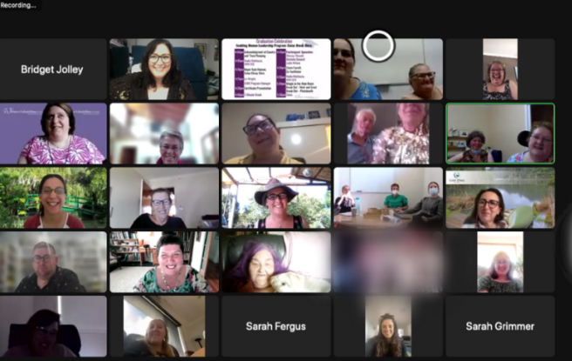
Image description: 2021 Colac Enabling Women Leadership Program Graduation on Zoom.

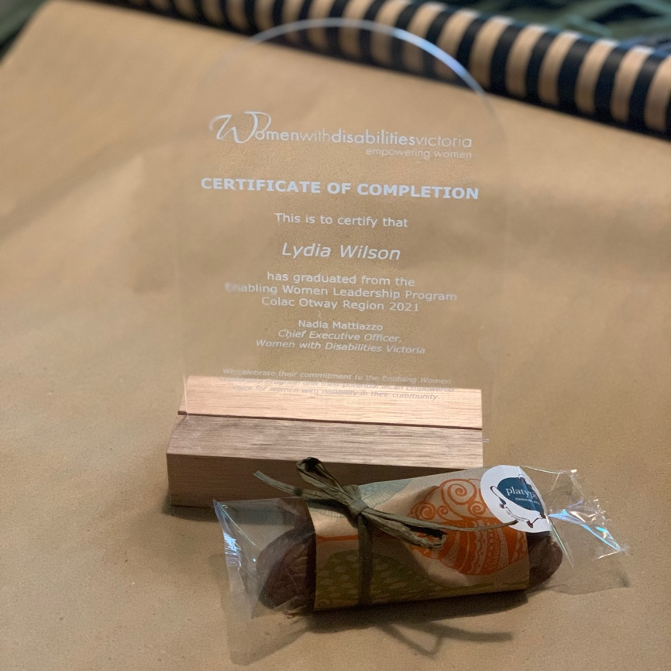
Image description: 2021 Colac Enabling Women Leadership Program Certificate of Completion.
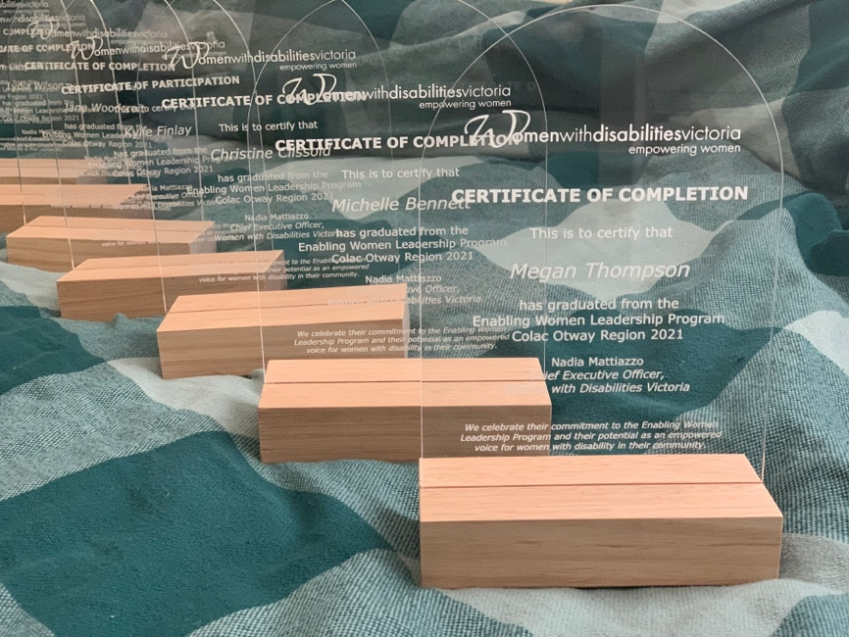
Image description: 2021 Colac Enabling Women Leadership Program Certificates of Completion.

Warrnambool - Victoria South West

Facilitator: Bridget Jolley
Co-facilitator: Jayne Harris
Mentor Coordinator: Erica Smith
Participants: 7

With the flexibility of participation allowed by online delivery, the 2022 Program welcomed women from across Warrnambool and the South West. Supported by local co-facilitator Jayne, Bridget and the participants formed a unique, tailor-made Program. With eased restrictions and safety protocols in place, the group got together for the first time in person for a wonderful graduation ceremony, that was streamed online for WDV’s continued commitment to hybrid.

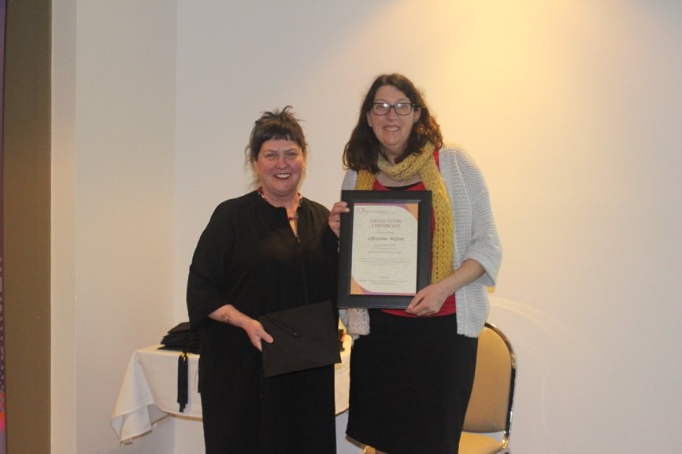
Image description: WDV’s Liz Wright with Christine who is holding a graduation certificate.
“I was lucky. I was encouraged by Jayne, who knew of my deafness. Otherwise, I wouldn’t even have heard of the program. I didn’t think of myself as a woman with a disability. I was used to the social problems of hearing loss and resigned to living in an increasingly isolated way. But not anymore.”
Enabling Women participant, 2022.
Victoria statewide - Youth

Facilitator: Bridget Jolley
Co-facilitator: Vanessa Davis
Participants: 12

The 2023 Enabling Young Women Program was full of firsts. The first truly hybrid program in delivery, the first Enabling Women hosted at the new WDV office, and the first Program available statewide! The group had a lot of fun learning about human rights through playing Bingo. The metaphor of plants as strengths was used to explore the topic of strengths as they decorated plant pots.

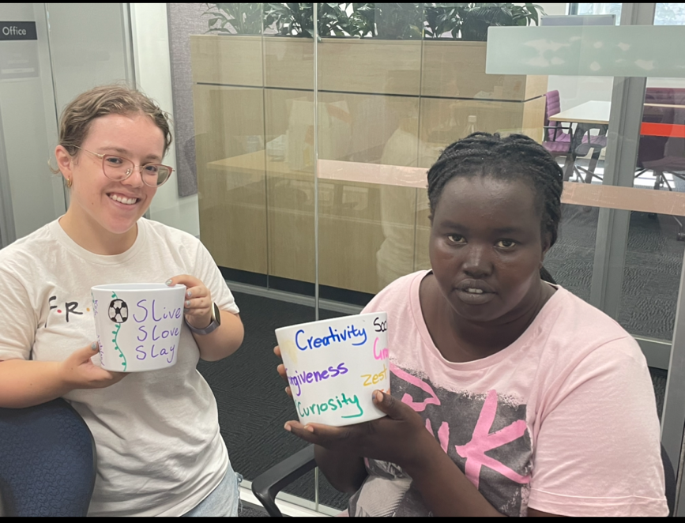
Image description: Program participants Julie and Nangoun show their plant pots that represent their strengths.
“Enabling Young Women is the most accessible leadership program that I’ve been a part of, and I’ve been part of a few. What I really like is that I feel really welcome to be my authentic self – no matter what that looks like on the day. And I don’t feel like I have to put on a mask or act in a certain way in order to present as a leader. It’s enough for it to be me, and that’s me as a leader.”
Enabling Young Women participant, 2023.

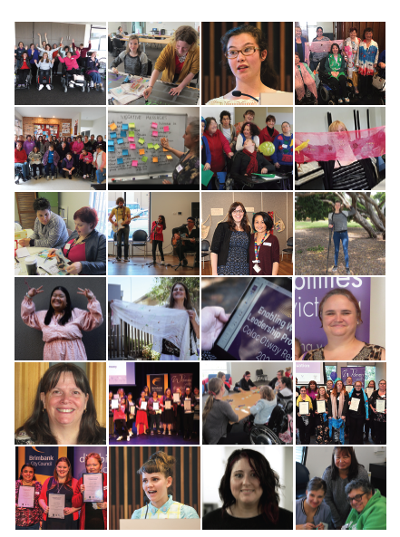
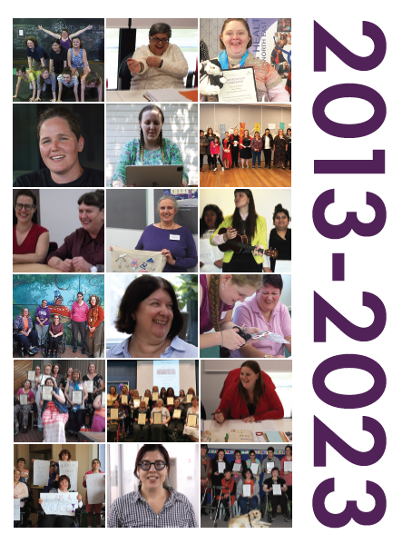Images description: Many pictures from the Enabling Women Leadership Program workshops, activities and graduations over the past ten years.
Media coverage
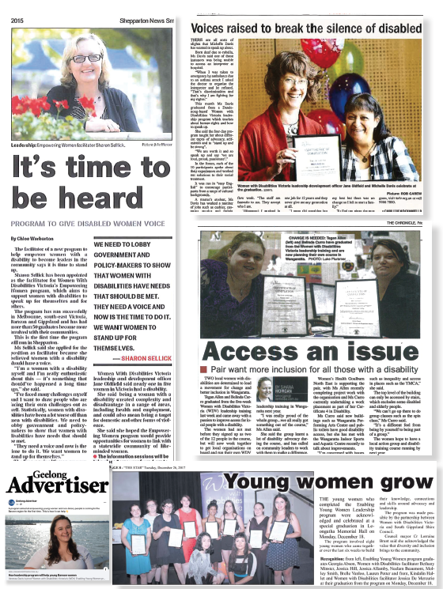
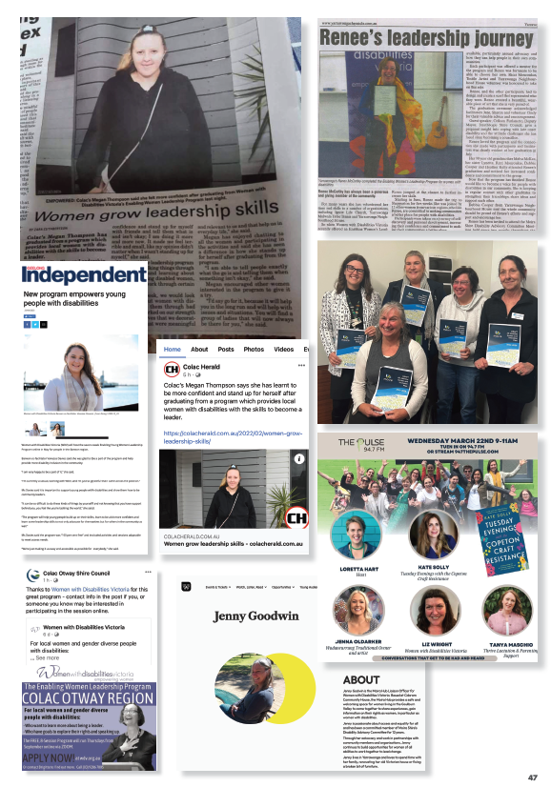

Images description: Different media articles about the Program.
Speeches, quotes and other reflections.

“I am proud of myself because of being in this program and it has been great and it has brought me out of my shell. I don’t feel so scared anymore. I know that I can talk about what I want and also have people to understand and listen to me. I know there is help out there if I need it. So, I will like to say again, thank you WDV for letting me be involved with this program.”
Enabling Women participant, Chrissy.

“I remember in my letter to myself I wrote that I would meet some awesome women. This, if anything, will be the highlight of participating in the program - the inspiration of others connecting and supporting each other. It has shifted that awkwardness within me about speaking up about my own disability. Part of me really does feel “loud, proud and passionate” for the first time in many years.”
Enabling Women participant, Sandra.

“Before [the Program] people would talk for me and it was frustrating. Now I speak. I have a voice.”
Enabling Women participant, Megan.

“This is one of the best programs I’ve ever seen.”
Reference Group Member.

“The first time I heard the word “empowering” it pushed me to say YES right away to my Support Coordinator when she told me about it. There’s something in that word that kicked my frustrated heart.”
Enabling Women participant, Grace.

“This program has helped me find my voice. It’s important that I use my voice not only for myself but for my children and for women like myself who have experienced illness and disability through trauma. So that women and children like me and my children are not continuing to be neglected and judged and discriminated against.”
Enabling Women participant, Jo.

“Fantastic program. Guest speakers and mentoring absolutely deadly!”
Enabling Women participant.

“I’m Jackie. I’m 59. I have an Intellectual Disability, learning difficulty. I live independently. I am very creative.

I am proud that I attended the Enabling Women Community Leadership Program. When I first started the program, I knew that I had a few qualities and strengths. The last week of the program I learned that I have more strengths.

I would like to remind myself that these strengths can help me achieve difficult challenges.

I would like to inspire other women with disabilities that they can achieve their goal in their daily life situations.”
Graduation speech by Enabling Women participant, Jackie.



Scan the QR code or visit WDV’s YouTube channel youtube.com/user/WDVchannel to watch selected Enabling Women Graduation speeches and other highlights.
Because of Enabling Women

The Hubs
In what began as members of the Enabling Women Torquay Program wanting to continue their advocacy journey with regular meetings, has now become a feature of WDV’s impressive line-up of Programs and Projects.

The regional Hubs are an integral part of the Community Inclusion and Women’s Empowerment team, alongside the Enabling Women Program. The relationship between the two Programs creates a pathway for participants to continue their learning and their advocacy.

Each hub is led by a Hub Liaison Officer, a peer who works with the WDV team to support their hub. They also work together to address local matters impacting on the lives of women and non-binary people with disabilities.

The Hubs are a vital resource for the entire WDV organisation too, who benefit from the grassroots nature and regional scope of the Hubs that help guide and inform WDV on policy and future projects.

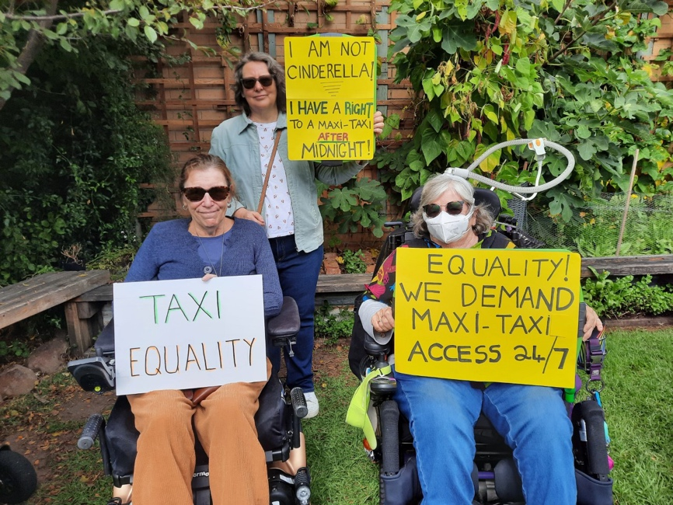

Image description: WDV Barwon Hub Members hold signs at a rally demanding taxi equality.

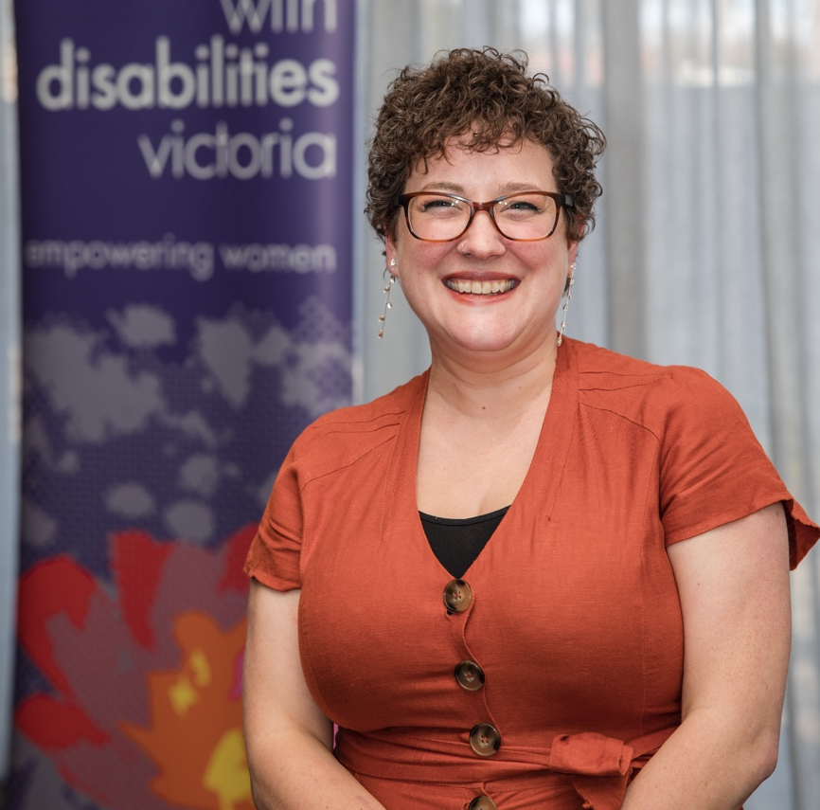
Image description: Emma Klemm, former Hub Liaison Officer at the Bendigo Hub launch.

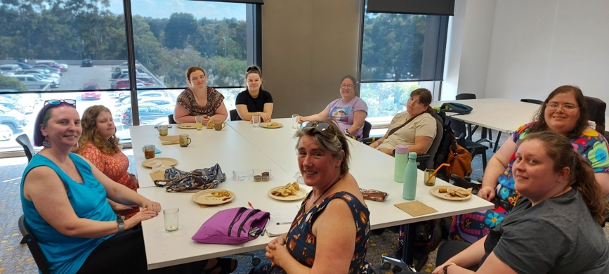
Image description: Members of the Outer Eastern Hub, sharing a meal together.

Leadership connections

Having peers as facilitators is an important aspect of the Program. Participant Casey agrees, “Really good, yeah was really friendly. I felt comfortable just being able to be myself. So that was really good.”

“You can actually feel you know, as Casey just said, it’s very comfortable… You’re with peers,” affirms Moira Hub Liaison Officer Jenny Godwin.

“You’re still different from each other but you all associate straight away with each other.

You know that you can relax and know that you’re in a safe, comfortable environment where you can just be yourself. It is actually probably one of the most lovely things about it. You can just watch the women, everyone develop confidence from that.”

“In the beginning I was at a crossroads,” shares participant, Mentor and Co-facilitator Renee.

“Like I knew that I was disabled but I didn’t realise where my life was headed and someone told me to look into doing Enabling Women in 2015…

“So I put my application in and I had no idea what I was getting myself into. Casey would agree, first day!

But then you get in and you work out you fit with all your other peers and you jump off ideas and it’s so comfortable. So, since then I have actually found my purpose and now I have been doing so much with Jenny and the Hub and using my skills with WDV as well.

And going out and about and changing people’s attitudes and perspectives which has been a big, huge stepping stone in change.”

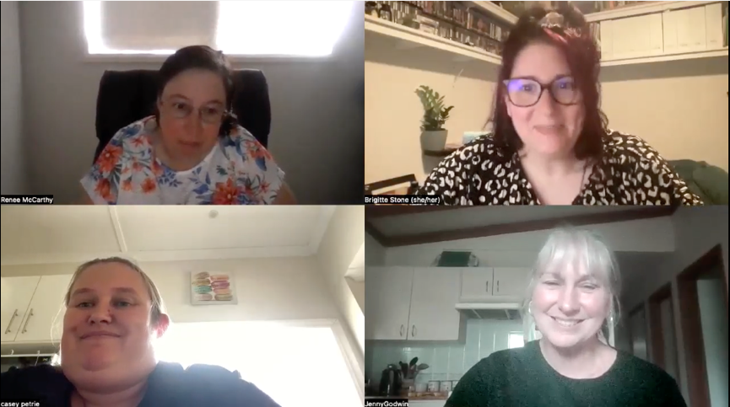

Image description: An online Zoom meeting of Moira Hub members and WDV staff including Jenny Godwin, Brigitte Stone, Renee and Casey.

Values Workshops:
PCE and Having a Say Conference

The Values Workshop was designed in 2022 to showcase some of the great themes of Enabling Women in a shorter, more flexible way.

The delivery of this Workshop has gone from a whole day to two hours, right down to an impactful 30 minutes! Online, in person, hybrid – this workshop has done it all.
The Values Workshop was proudly presented at the Having a Say Conference in 2023 and 2024.

In 2024 the Community Inclusion and Women’s Empowerment team also set up at the Our Rights Expo, alongside the conference. The Values Workshop has also been delivered at the WDV office with groups like our friends in Power and Culture in Ethnicity (PCE).

Together the groups, which have ranged from two to 42 attendees, explore negative messages and ways to overcome them by building up self-esteem, self-care and positive messages.

Delivering these workshops is a great opportunity for the WDV team as it gives an opportunity to work with other groups and learn about their experiences too.

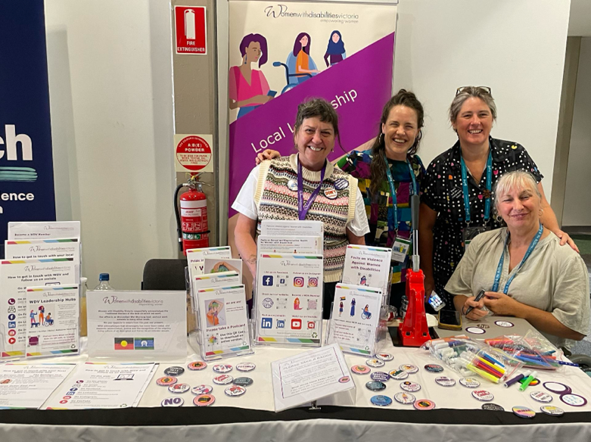

Image description: WDV staff at the 2023 Our Rights expo.
Other projects and events

Over the last ten years, the Enabling Women Program has led to many other projects and events. Examples include:

- Women Leading By Example – a two day program focusing particularly in the area of intergenerational leadership.
- A series of NDIS workshops.
- Spotlight on Invisible Women – an evaluation report focusing on the lives of women with disabilities aged 50-65 years of age.
- 2023 International Women’s Day Campaign.

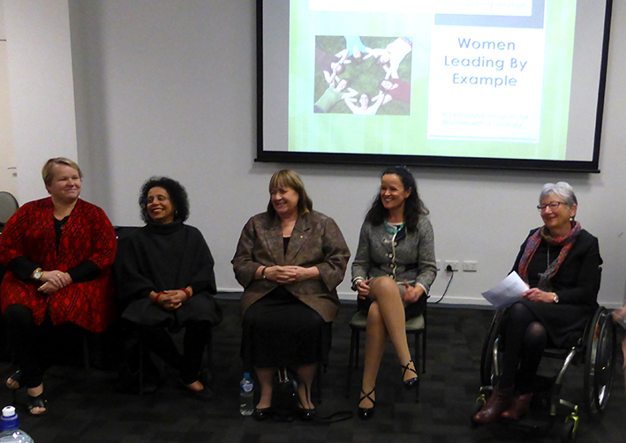
Image description: Attendees at the Women Leading By Example Program.

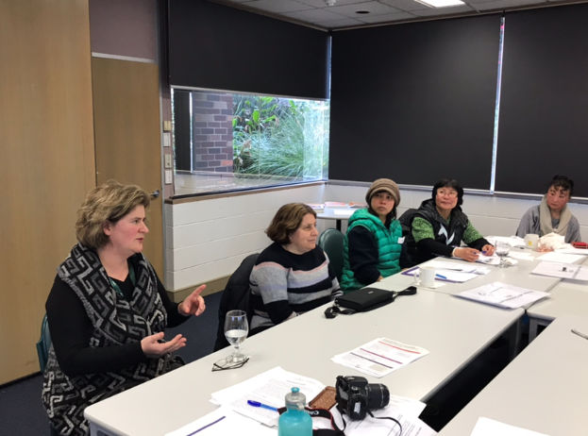
Image description: Attendees at a NDIS workshop in Footscray.
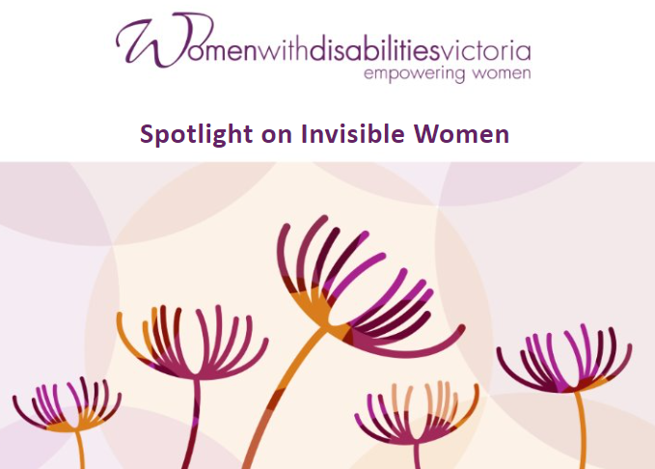
Image description: Title page for a Spotlight on Invisible Women Presentation.

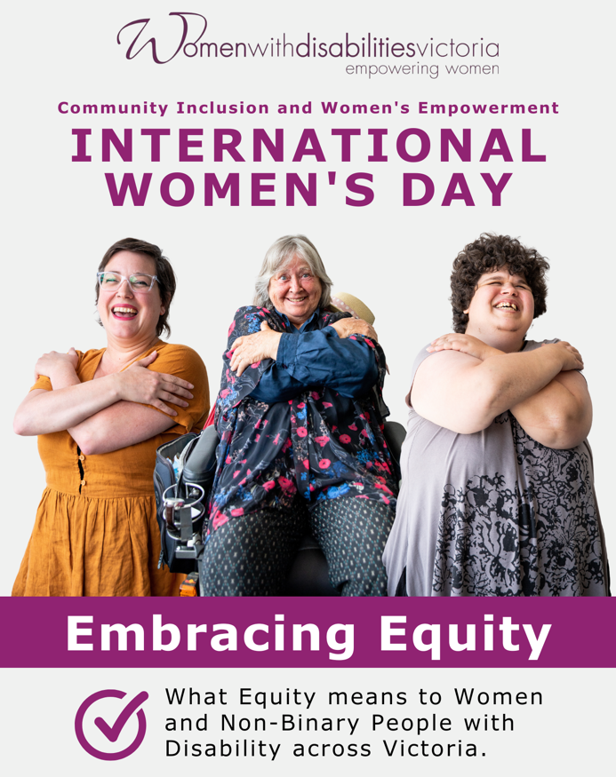

Image description: Cover page for WDV’s 2023 International Women’s Day campaign – Embracing Equity.
Youth projects

In continuing our commitment to supporting the empowerment of youth - in 2021, WDV set up a Youth Project Co-Design Group (YPCG).

Seven young women and non-binary youth with disabilities met regularly over six months and together came up with 12 recommendations.

WDV started implementing these recommendations, including in 2022, beginning the organisation’s third Experts by Experience group.

The Youth Experts by Experience continue to meet regularly to plan and deliver events and resources spotlighting youth perspectives. These include:

- Lead Your Way, a series of four online workshops to support youth leadership.
- Pride in Conversations, a hybrid event spotlighting the combined experiences of LGBTQIA+ gender, age, and disabled identities.
- Disability Representation in #LoveOzYA, an online event discussing disability representation in young adult literature.

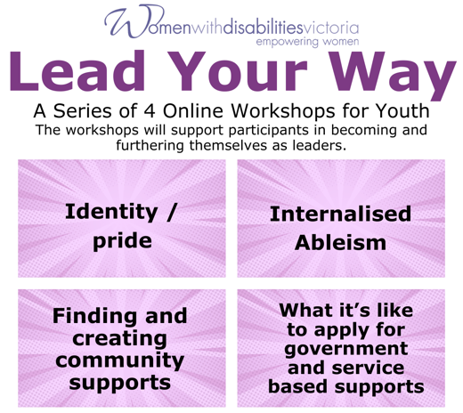

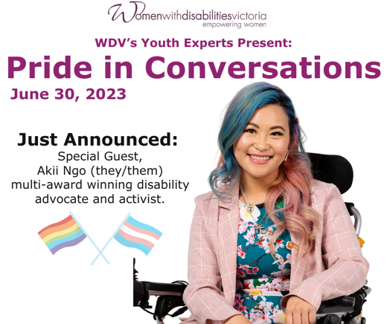

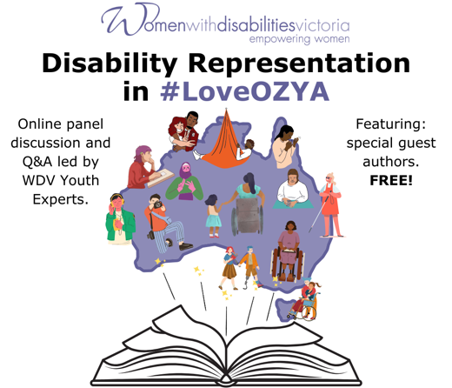

Image description: Media tiles promoting Lead Your Way workshops, and the events Pride in Conversations, and Disability Representation in #LoveOzYA.
Finding my Bia, Greek Goddess of
Force, Might and Power

I didn’t face this path alone
I met you all from within my home.

We worked together yet we were all apart
At our own pace we made a start.

We got to know each other well
Each our own journey we all would tell.

I learned that I could be strong and proud
Confidently now I can say it out loud.

I’ve always wanted to go away
Just pack the car for a weekend stay.

This course taught me things I could do
That I have a right just like you.

To colleagues I’ve met along the way
The eight weeks together, I’ve made good friends today.

I have many rights and I’m not alone
Because of this journey I’ve truly grown.

Thank you to WDV for all you’ve taught me
I’m now ready to face
the next chapter of my life with confidence.

A poem by Enabling Women participant, Shelley.
Enabling Women video

As part of the ten year anniversary celebrations for the Enabling Women Leadership Program, a video series was created. Along with WDV staff, five past participants were interviewed, where they share their experience of the Program, and how it has empowered them to become leaders in their own ways.

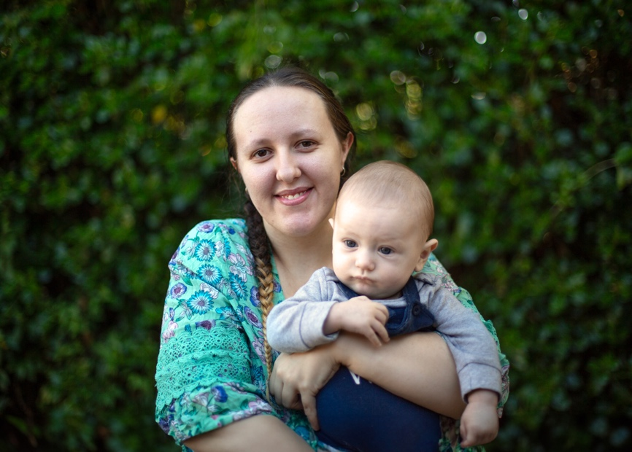

"The Program has helped me become a leader in my life because it helped me stand up for what I believe in and stand up for the people who I love and have the confidence to believe that I can do anything I put my mind to."

Megan Thompson
2021 Enabling Women participant.

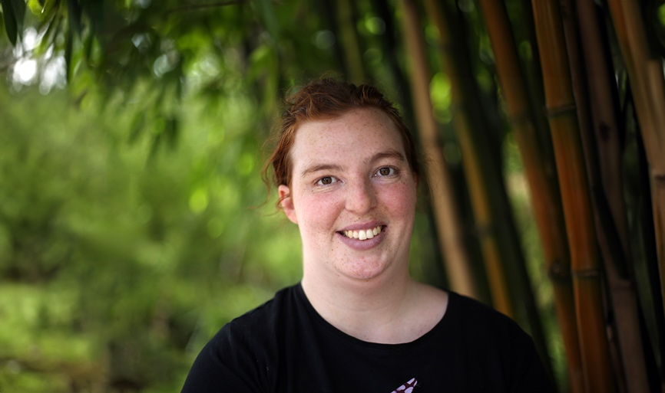

"The Program definitely helped me achieve my goals, for sure. I definitely think I came out of it as a lot more confident and a lot more outspoken. And being able to stand up for myself and for other people."

Megan Dunne-Riseley
2018 Enabling Women participant.

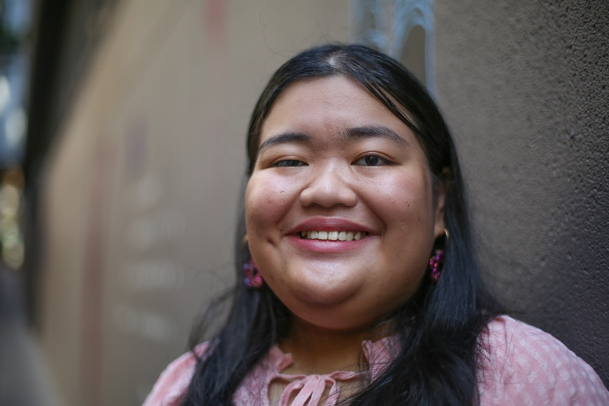

“I feel more able to share my opinions with other people, and I feel like, you know, being a leader someday is something that I can actually aspire towards.”

Julia Coscolluela
2023 Enabling Young Women participant.

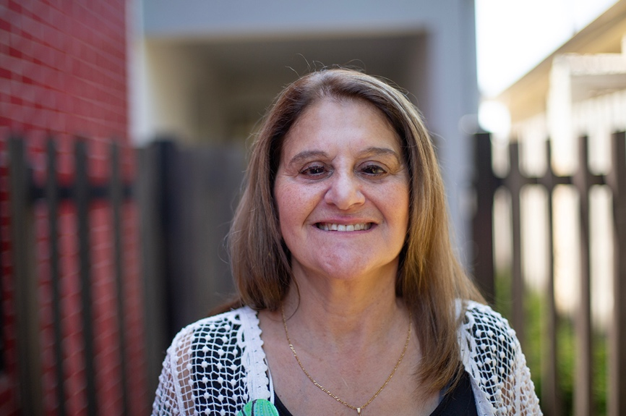

"To be confident the way I have become, I have also blossomed from doing this course, having some fantastic networks and also some amazing friendships through Women’s Disability Victoria."

Marie Allen
2014 Enabling Women participant and 2018 Co-facilitator.

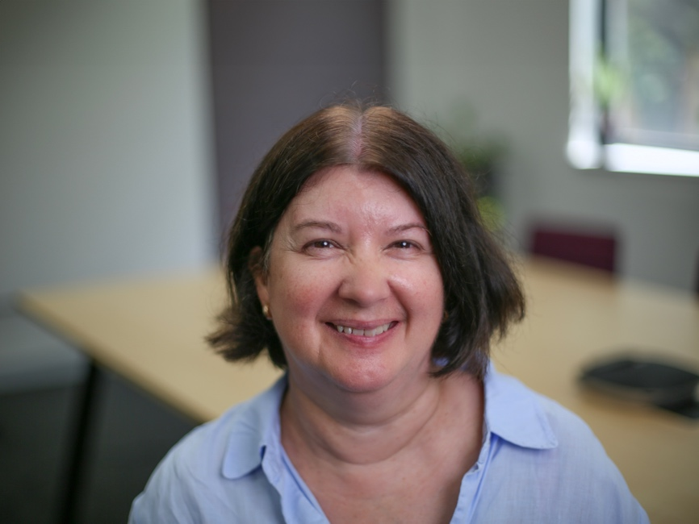

"I think that the Program has been so successful because it’s really important for women to connect with other women with disabilities. And it’s really empowering to hear what our rights are."

Kerrie Forber
2017 Enabling Women participant.


The videos are available on WDV’s YouTube channel, which can be accessed via the QR code and youtube.com/user/WDVchannel.

Loud, Proud and Passionate!

In every nation in every land there is the dawning of a new day
No more separation we are hand in hand we are the dawning of a new way.

We’re loud proud, loud proud passionate, loud, proud, yeah! yeah! yeah!
We’re loud proud, loud proud passionate, loud, proud, yeah! yeah! yeah!

Disabled warriors fighting for the girls making our dreams come true
Knocking down the barriers, changing the world there is nothing we can’t do.

We’re loud proud, loud proud passionate, loud, proud, yeah! yeah! yeah!
We’re loud proud, loud proud passionate, loud, proud, yeah! yeah! yeah!

With love by getting closer to each other our hearts are overwhelmed
By hope and getting together we unite the nations
Come with us, we came to you, put your hands in our hands
Let’s make our dreams come true.

We’re loud proud, loud proud passionate, loud, proud, yeah! yeah! yeah!
We’re loud proud, loud proud passionate, loud, proud, yeah! yeah! yeah!

We are women manifesting our dreams women united we fight and will win we are warriors growing in this life taking our space searching for dignity.

We’re loud proud loud proud passionate loud proud yeah yeah yeah
We’re loud proud loud proud passionate loud proud yeah yeah yeah
La la la la la la laaa…

The Loud, Proud, Passionate music video was created at Mobility International USA’s 5th International Women’s Institute on Leadership and Disability.



The full version can be found at Loud, Proud and Passionate! (sm) Music Video (Captioned; text description available) at: youtube.com/watch?v=uxxomUVsSik or via the QR codes.

Selected references

Gippsland Women’s Health partnership
WDV partnered with Gippsland Women’s Health who established a reference group in order to continue the program independently in Gippsland. Since 2014 the Reference Group has run several programs, across six locations in Gippsland including:

- 2019 Bairnsdale
- 2018 Sale, Morwell and Wonthaggi
- 2017 Leongatha and
- 2016 Bairnsdale and Leongatha.

Women with Disabilities Victoria: Claiming Our Future, 2010.
Compiled by Rosemary Francis and Nikki Henningham, in partnership with the staff and membership of Women with Disabilities Victoria.

Loud, Proud and Passionate!
Copyright 2011 Mobility International USA.

Thank yous
Women with Disabilities Victoria would like to thank everyone who has been involved in the Enabling Women Leadership Program over the last ten years.

Thank you to our partners and funders. Your assistance and support has enabled these programs to exist and flourish.

To all the participants, Co-facilitators, Mentor Coordinators, Reference Group Members, volunteers and WDV staff, thank you for your participation, ideas, dedication and commitment.

Together we have built a program that empowers us all.

